**Changing Catholic Ministry**

**a Study Day incorporating MMaC AGM**

Date: Friday 3 November 2017

Venue: St. Etheldreda's church crypt, Ely Place

LONDON EC1N 6RY

Time: 10am - 5pm

There is NO CHARGE for the day but please bring food to share for lunch.

**This event is being organised by three groups:**

* Movement for Married Clergy
* Catholics for a Changing Church
* International Federation

for a Renewed Catholic Ministry.

**Our speakers:**

* **Joe Fitzpatrick** is a Scot who lives in Yorkshire, A former Inspector of Schools and a catholic priest who resigned his public ministry to be free to marry. Joe is a member of MMaC

He is the author of Philosophical Encounters: Longeran and the Analytical Tradition and The Fall and Ascent of Man

* **Bridie Stringer** is Lecturer in Pastoral Theology at St. Mary's University, Twickenham. She had worked in the telecommunications industry and in NHS management.

In 2013 she published Baptising Babies and Clearing Gutters: a Fresh Appraisal of the Permanent Diaconate

* **Anthony Padavano**, an American theologian, holding doctorates in theology and literature, author of 29 books, including three award-winning plays, translated into nine languages: visiting professor at 25 American colleges and universities, lectures world-wide and appears regularly in the media on both sides of the Atlantic.

**Our programme for the day:**

* 10.00 registration and coffee
* 10.30 welcome to the study day

Followed by our first speaker

and discussion

* 11.45 break
* 12.00 second speaker/discussion
* 13.00 lunch break
* 14.00 separate meetings for

IFRCM and MMaC. This meeting will constitute the AGM 2017 for MMaC.

* 15.00 our final speaker and summary discussion for the day
* 17.00 Departure

**DIRECTIONS to Ely Place:**

St Etheldreda's is in Ely Place, an historic gated road off Holborn Circus in central London. Some limited on-street parking in Ely Place ­­- congestion charge applies

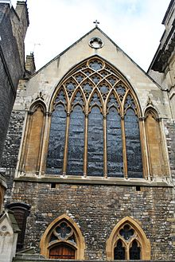

Tube stations: Chancery Lane - Central: Farringdon - Circle, City and Metropolitan

Overground trains Farringdon and City Thameslink

By bus: 8 N8 25 242 390 521 stop on High Holborn 63 on Farringdon Road

Or by taxi

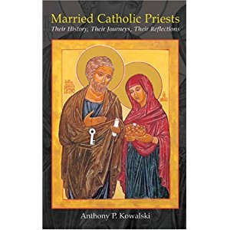

**MMaC Annual General Meeting**

We have experienced considerable difficulty managing AGM meetings in the last couple of years, for two reasons.

* Our membership is scattered across the whole of the country.
* Our membership is towards the older end of the spectrum and so travel is not always easy.

We need to formally approve each year the membership of your MMaC committee and for you to receive reports of our activities on your behalf.

We already do so through two Newsletters a year and the recently introduced eBulletin mailing. The now much- expanded website gives access to recent articles and news for your information.

Your present committee are willing to serve your interests for another year.

We are always open to suggestions for direction and development from you in order to pursue the mission statement of MMaC. We hope to discuss present initiatives during the Friday afternoon session. Each member will receive a summary of proceedings in the January Newsletter.

Chris McDonnell secretary MMaC

Your current committee:

Chair Mike Kerrigan, Secretary Chris McDonnell, Treasurer Bob Hughes

Committee members:

Fr David Stanley, Elizabeth Price, Bishop Crispian Hollis, Pam Wearing