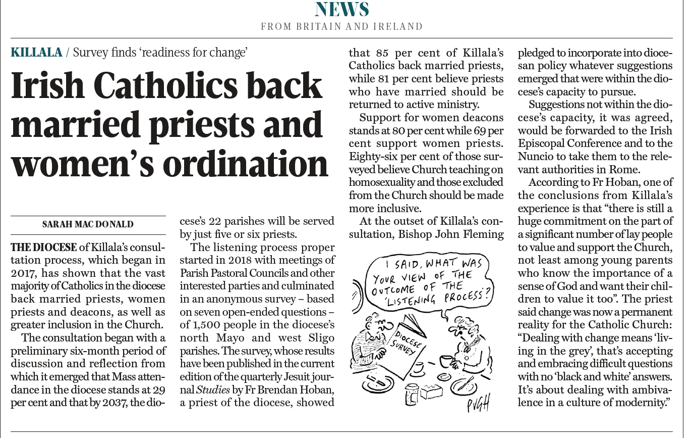
The Tablet, 28 September 2019
See also: https://novenanews.com/majority-catholics-killala-ireland-married-women-priests-lgbtq/
https://www.irishexaminer.com/breakingnews/ireland/bishop-backs-parishioners-who-want-female-priests-952450.html
https://www.killaladiocese.org/300-parish-delegates-to-attend-first-ever-diocesan-assembly/

