Top European cardinals want changes on homosexuality, priestly celibacy

By Elise Ann Allen

Feb 4, 2022
|Senior Correspondent
Share

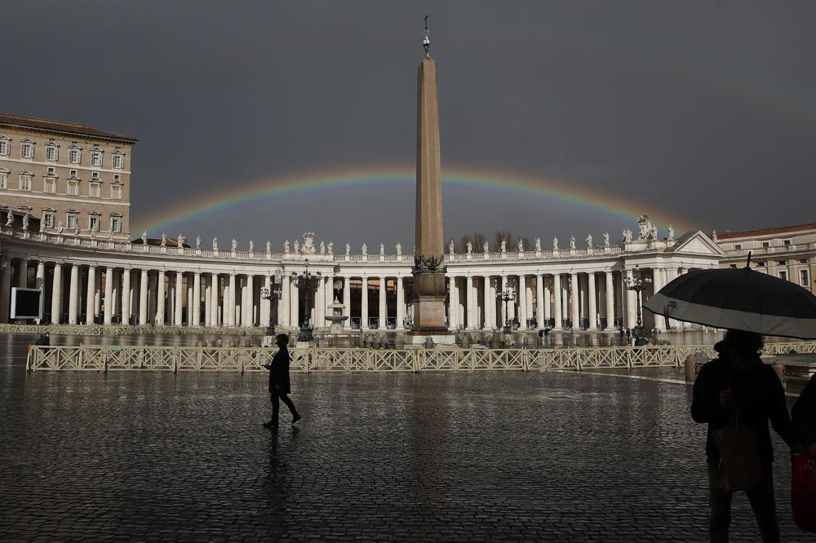
A rainbow shines over St.Peter’s Square at the Vatican, on Jan. 31, 2021. (Credit: Alessandra Tarantino/AP.)
Listen to this story:
ROME – Over the past week, two leading European cardinals, both of whom enjoy broad favor with Pope Francis, have made public statements calling for a change in the Catholic Church’s current position on the issues of homosexuality and priestly celibacy.
In an interview published in Germany’s Catholic News Agency (KNA) earlier this week, Jesuit Cardinal Jean Claude Hollerich, Archbishop of Luxembourg, voiced his belief that the Church’s position viewing homosexual relationships is wrong.
“I believe that the sociological-scientific foundation of this teaching is no longer correct,” he said, saying the time has come to revise this position, and suggesting that Pope Francis’s own rhetoric on homosexuality could open the door for this change to take place.
Since the beginning of his pontificate, Pope Francis, who has also voiced concern over homosexuality in the priesthood, has taken a softer approach to the issue and has urged the Church to be more welcoming to homosexual individuals and to families with homosexual members.
In 2013, he signaled a new approach to the issue with his famous declaration that if a person “is gay and is searching for the Lord and has good will … Who am I to judge?”
In 2018, he said that the Church has to find a way to help the parents of gays and lesbians so that they “stand by” their children, telling parents with LGBT children, “Do not condemn. Dialogue. Understand. Make space for the son or daughter; make space so they express themselves.”
During an interview in 2019, Francis said he does not think it’s rare for parents to have a homosexual child and said that homosexual tendencies “are not a sin,” insisting that tendencies themselves “are not sin. If you have a tendency to anger, it’s not a sin. Now, if you are angry and hurt people, the sin is there.”
Last year, he met with a group of parents of LGBT children, telling them that God loves their children as they are, and that the Church loves them because they are “children of God.”
Earlier this month, during one of his general audience speeches, the pope said he thinks often about parents struggling with problems their children are facing, including “Parents who see different sexual orientations in their children” and who struggle with “how manage this and accompany the children without hiding behind a condemning attitude.”
In addition to overseeing the Archdiocese of Luxembourg, Hollerich also serves as president of the Commission of the Bishops’ Conferences of the European Union (COMECE) and over the summer was appointed by Pope Francis to the significant role of Relator General for the ongoing Synod of Bishops on Synodality. He was made a cardinal by Francis in 2019.
His remarks on homosexuality come in response to a public campaign by 125 Catholic Church employees in Germany who recently outed themselves as homosexual, saying they wanted to “live openly without fear” in the Church.
In the interview, Hollerich said it is important that the Church remain human, and admitted that he knows of homosexual priests and laypeople in the Archdiocese of Luxembourg.
“They know that they have a home in the church,” he said, adding, “With us, no one is dismissed because they are homosexual, with us no one has ever been dismissed because of that.”
Even divorced and remarried people without an annulment are active in his archdiocese, Hollerich said, insisting that, “I can’t kick them out…They would become unemployed. How can such a thing be Christian?”
Hollerich also made waves in the interview for suggesting that his fellow cardinal, Cardinal Ranier Woelki of Cologne, who is on a papal-mandated sabbatical until March following intense public backlash over his handling of clerical abuse cases, should resign.
“It seems that the archbishop is no longer welcome in his diocese among a large majority,” Hollerich said of Woelki, adding, “If that’s what happened to me, I would tender my resignation.”
While Woelki has not brought any blame on himself in the review of abuse cases and while he has devoted himself to child protection, “he has very poor communication,” Hollerich said, and criticized Woelki’s decision not to publish the results of an initial report he had commissioned into abuse in the Archdiocese of Cologne.
“You can’t do that in the digital age,” he said, and admitted that he found it “difficult” that the cost of the legal reports Woelki commissioned exceeded payments the archdiocese had made to victims. “In that case something is wrong,” he said.
According to information released by the Archdiocese of Cologne, Woelki spent roughly 2.8 million euros ($3,2 million) on legal experts, media lawyers, and communication consultants from 2019 to 2021 as part of his inquiries into abuse in the archdiocese, whereas only 1.5 million euros ($1,7 million) has been paid to victims of clerical abuse since 2010.
Cologne Auxiliary Bishop Rolf Steinhäuser, the current administrator of the Cologne archdiocese, has ordered a review of the contracts over concerns that key church committees might have been ignored in the process of awarding them.
Hollerich said that if he were in Woelki’s position, he would “go to a parish somewhere. A student community, for example,” adding, “As a Christian, I don’t have to be at the top to live my faith.”
Elsewhere in Europe, another top prelate and close papal aide, German Cardinal Reinhard Marx is making waves over recent comments in an interview stating his belief that the Church ought to change its stance on mandatory priestly celibacy.
Speaking to German daily Sueddeutsche Zeitung, Marx said “it would be better for everyone to create the possibility of celibate and married priests.”
Currently the archbishop of Munich and Freising, Marx is a former leader of the German bishops’ conference and is also a member of the pope’s council of cardinal advisors.
His remarks on priestly celibacy come as his archdiocese is still reeling from an independent report into its handling of clerical sexual abuse cases over several decades. Marx was faulted in the report as well as several predecessors, including retired Pope Benedict XVI, who led the archdiocese from 1977-1982.
Marx, known as a progressive reformist who enjoys the pope’s favor, said after the Munich abuse report’s publication that a deep reform is needed if the Church is to overcome the “disaster” of clerical abuse.
In the interview, Marx said that “For some priests, it would be better if they were married – not just for sexual reasons, but because it would be better for their life, and they wouldn’t be lonely. We must hold this discussion.”
In his vision, celibacy would not be eliminated entirely, Marx said, but admitted that he sees a “question mark” as to whether “it should be taken as a basic precondition for every priest.”
The topic of priestly celibacy and advocacy for optional celibacy is not new for Marx, who voiced support for a limited openness to the married priesthood during the 2019 Synod of Bishops on the Amazon as a possible solution to the regional priest shortage.
Priestly celibacy has also been an open topic of debate throughout the German Catholic Church’s “synodal path” reform process, which was launched in response to the country’s clerical abuse crisis. The latest session of the process began Thursday.
Last summer Marx announced that he had submitted his resignation to Pope Francis in a bid to accept responsibility for the Church’s systemic failure to properly address the abuse crisis. The pope declined his resignation a few days later.

