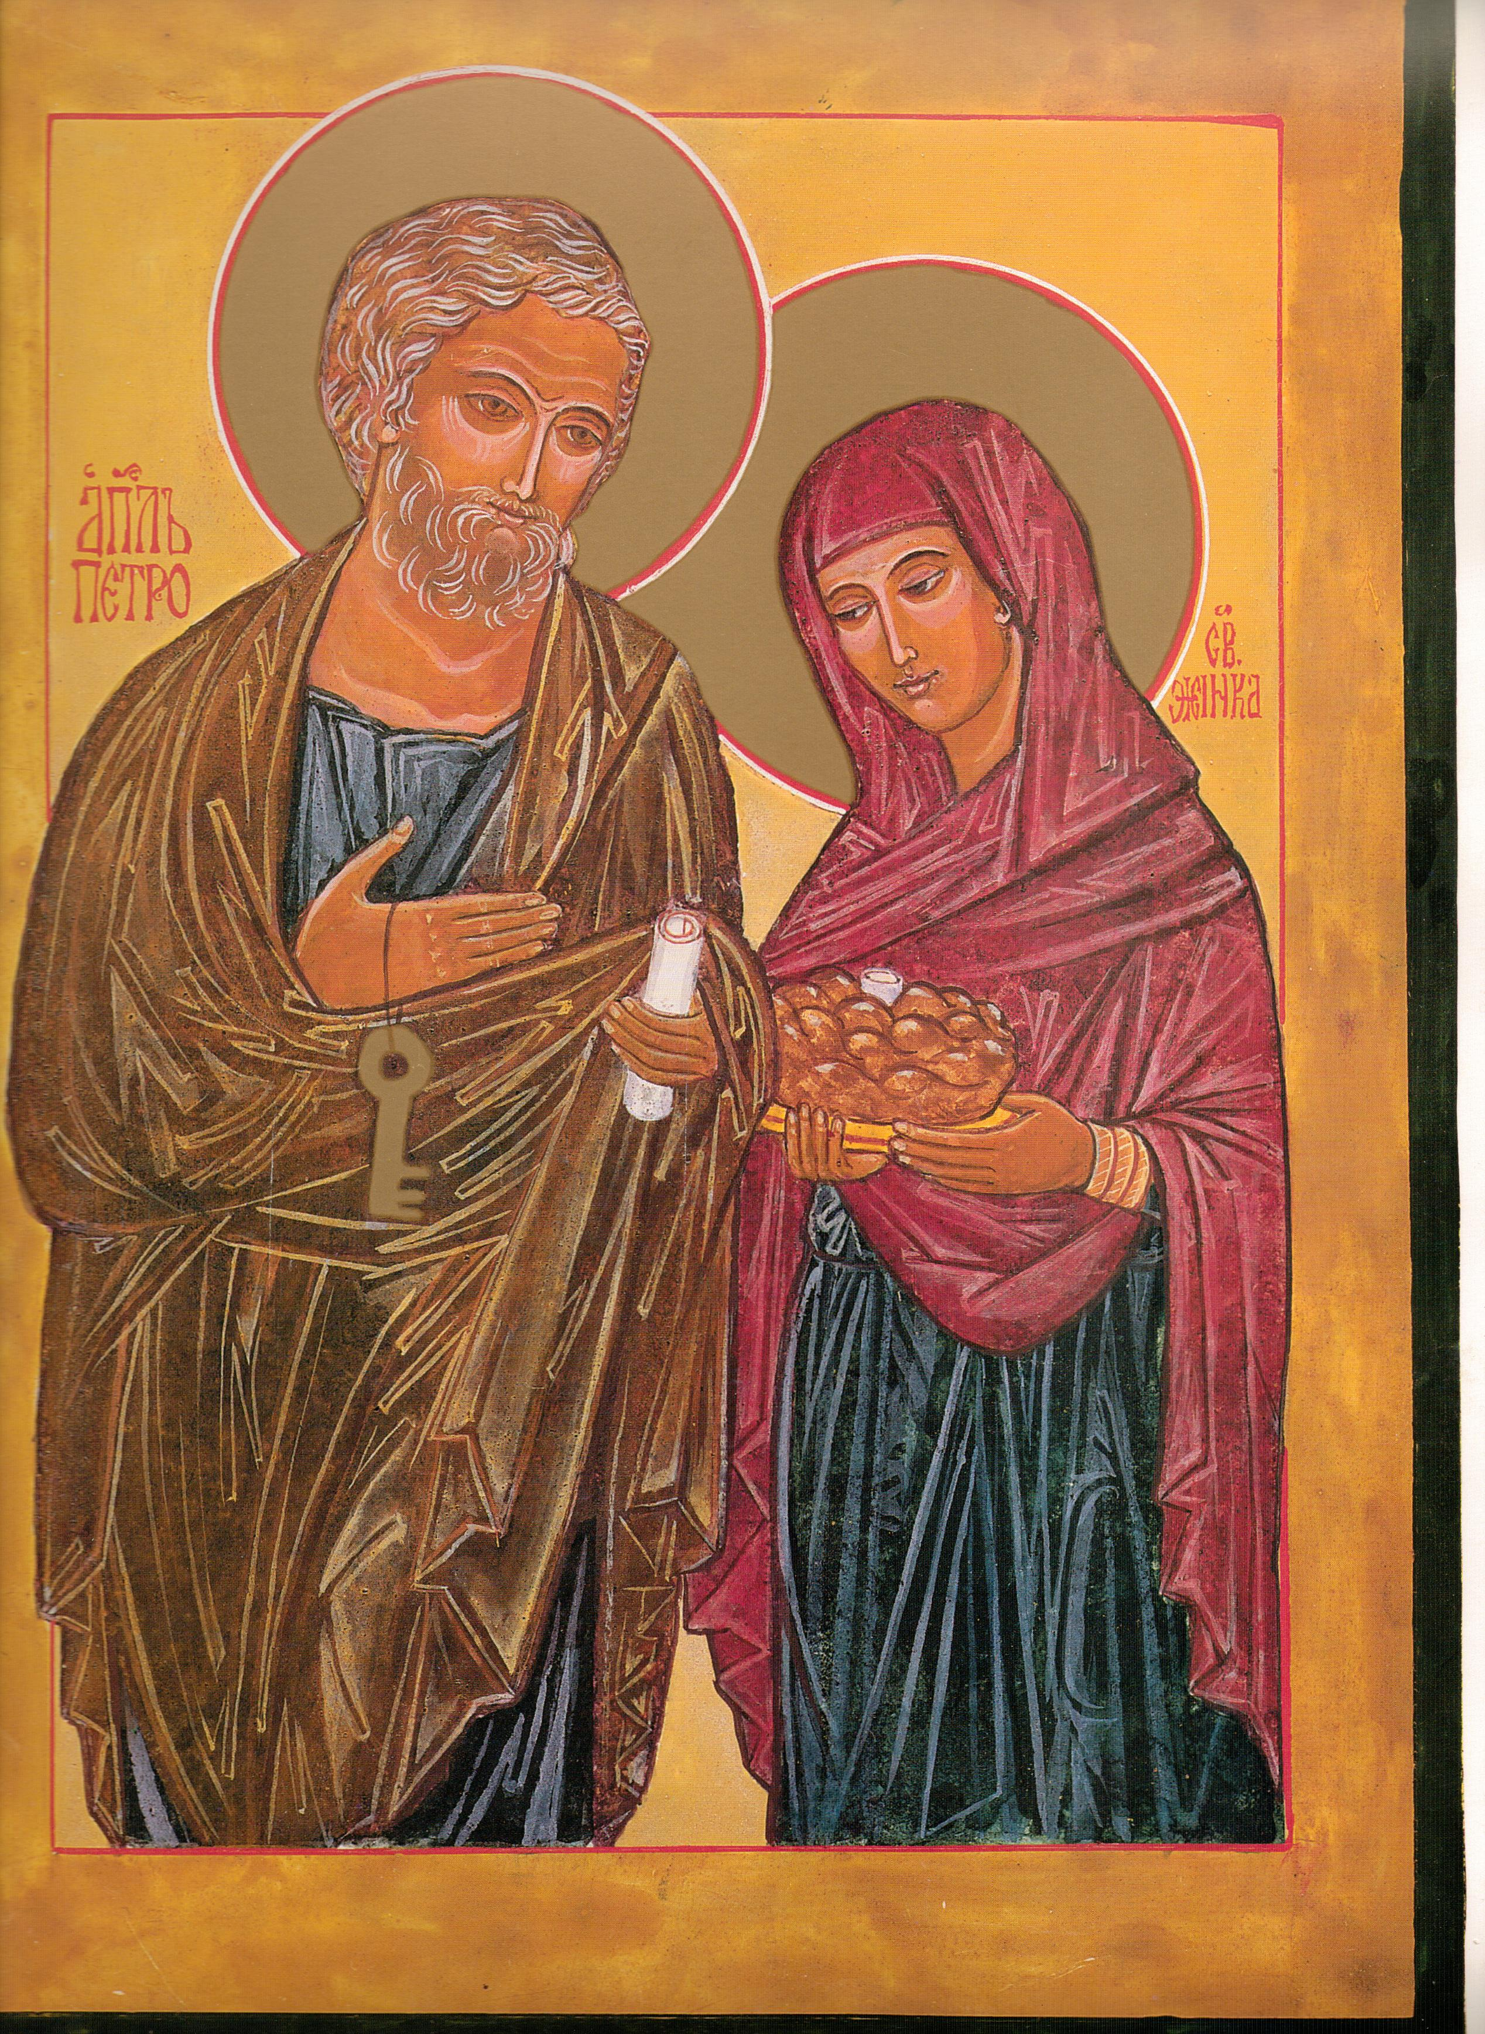
Mmac
Movement for married clergy

Newsletter August 2013

Chair Secretary

Dr Michael Winter Chris McDonnell

13 Foxham Road 1 High Chase Rise
LONDON Little Haywood Staffs
N19 4RR ST18 OTY 01 889 881 514 m.m.winter@btopenworld.com chris@mcdonnell83.freeserve.co.uk

My apologies for the delay in getting this Newsletter to you. We usually try to get the copy in the post as soon as possible after the June AGM. Due to personal circumstances that has not been possible this time.
However, let’s catch up on a few matters.
First, a few words from our Chair, Dr Michael Winter

CHAIRMAN'S MESSAGE. Dear Friends, If you are reading this, it means that you are an active member of MMaC, so my first thought is to thank you sincerely for your support.
The few months since the January newsletter have been the most dramatic for our movement, since its inception in 1975. In April Cardinal K. O'Brien, five days before normal retirement, announced his support for married priests. I wrote and thanked him, and invited him to become a member of MMaC. Within a few days his circumstances dramatically changed and his world fell apart.
Shortly after that, Pope Benedict resigned, and Pope Francis was elected. He reminds me of John XXIII, and his simplicity and optimistic attitude to life have already transformed the morale of the Church. Signs of hope are apparent all over the place. Clearly his first priority is the reform of the scandals swirling round the Vatican Bank. Of all the popes who have led us (now 7 in my lifetime !), Francis seems to be the most likely to authorise the ordination of married men. Personally I am optimistic.
Since his election about eight biographies have been rushed into print. The best is that by Paul Vallely (Bloomsbury £ 11.99). He suggests that the pope has a memory which is not reassuring to him. Something to do with a decision about two Jesuits when he was their provincial during the military dictatorship. This may well be a positive advantage. I seem to remember that the first pope had an experience which had reduced him to tears. And St. Paul's life was haunted by the memory that had once persecuted the Church. Please continue your support of MMaC, by trying to recruit just one new member.

You will see advertised in the Tablet over the next two weeks, a presentation by Dr Eamon Duffy, Professor of the History of Christianity in the University of Cambridge at the invitation of our Movement, on Saturday afternoon, September 21st at the Catholic chaplaincy in the University of Birmingham.

“Celibacy and the pastoral priesthood since the Council of Trent”

There will be refreshments from 2pm, with Professor Duffy beginning his paper at 2.30pm. Please book your place through an email to the secretary. You will then receive further details and directions to the chaplaincy by return. We are limited to 80 places, so please book early.

We welcomed to our AGM this year Fr Peter Cornwell, who gave the limited number of attendees a very good oversight of his own experience after 25 years in the Anglican ministry and a further 25 years since ordination in the Catholic church. The full text is available on our website:
www.marriedclergy.co.uk
The website has continued to expand and attract attention since the new site went live in February this year. Our thanks must go to Michael Kerrigan for his time and effort in this regard. Please give the address to your friends who may wish to support our work and try to ensure that the address is publicised through your parish.

We continue to make every effort to keep the purpose and intention of MMac in the public domain. Apart from the occasional letter to the Tablet, might I suggest you also check out Letters Extra on their website, where further comments have been published. The Herald, Universe and Times and also made aware on a regular basis of our concern for choice in the matter of marriage for those men who seek the sacrament of ordination. Do please make your own views known when ever there is a suitable forum.
Recently, the Pray Tell website in the US carried a posting of mine “Sorry, no mass today” which gained 83 responses. That gave me opportunity to mention our group and direct interested people to the website. If you haven’t read Brendan Hoban’s book, “Who will break bread for us” which I refer to, then please do so. It is stark in its analysis of the Irish Church- available through the ACP website.

Our committee for the coming year:
Chair Dr Michael Winter , Secretary Chris McDonnell, Website Michael Kerrigan, Treasurer Bob Hughes. Committee: David Standley, Elizabeth Price, Roy Smith, Pam Wearing. We accepted the retirement of Ianthe Pratt and thanked her for her service to MMaC.

We are still awaiting a number of outstanding subscriptions for MMaC this year. These should be sent to the Treasurer as soon as possible. Robert Hughes, 11 Lawrence Leys, Bloxham, Near Banbury Oxon OX15 4NU
Joint membership is available for spouses for the payment of ONE subscription each year.
All members of a religious community may join for the payment of ONE subscription each year. If this is desired, please list the names of ALL those who wish to be considered members on the reverse of this sheet. The annual subscription, payable in January each year, is £15.
For students and those who are unemployed or retired, it is £8.
Chris McDonnell Secretary MMaC

