.
Mmac

Movement for married clergy
http://www.marriedclergy.co.uk
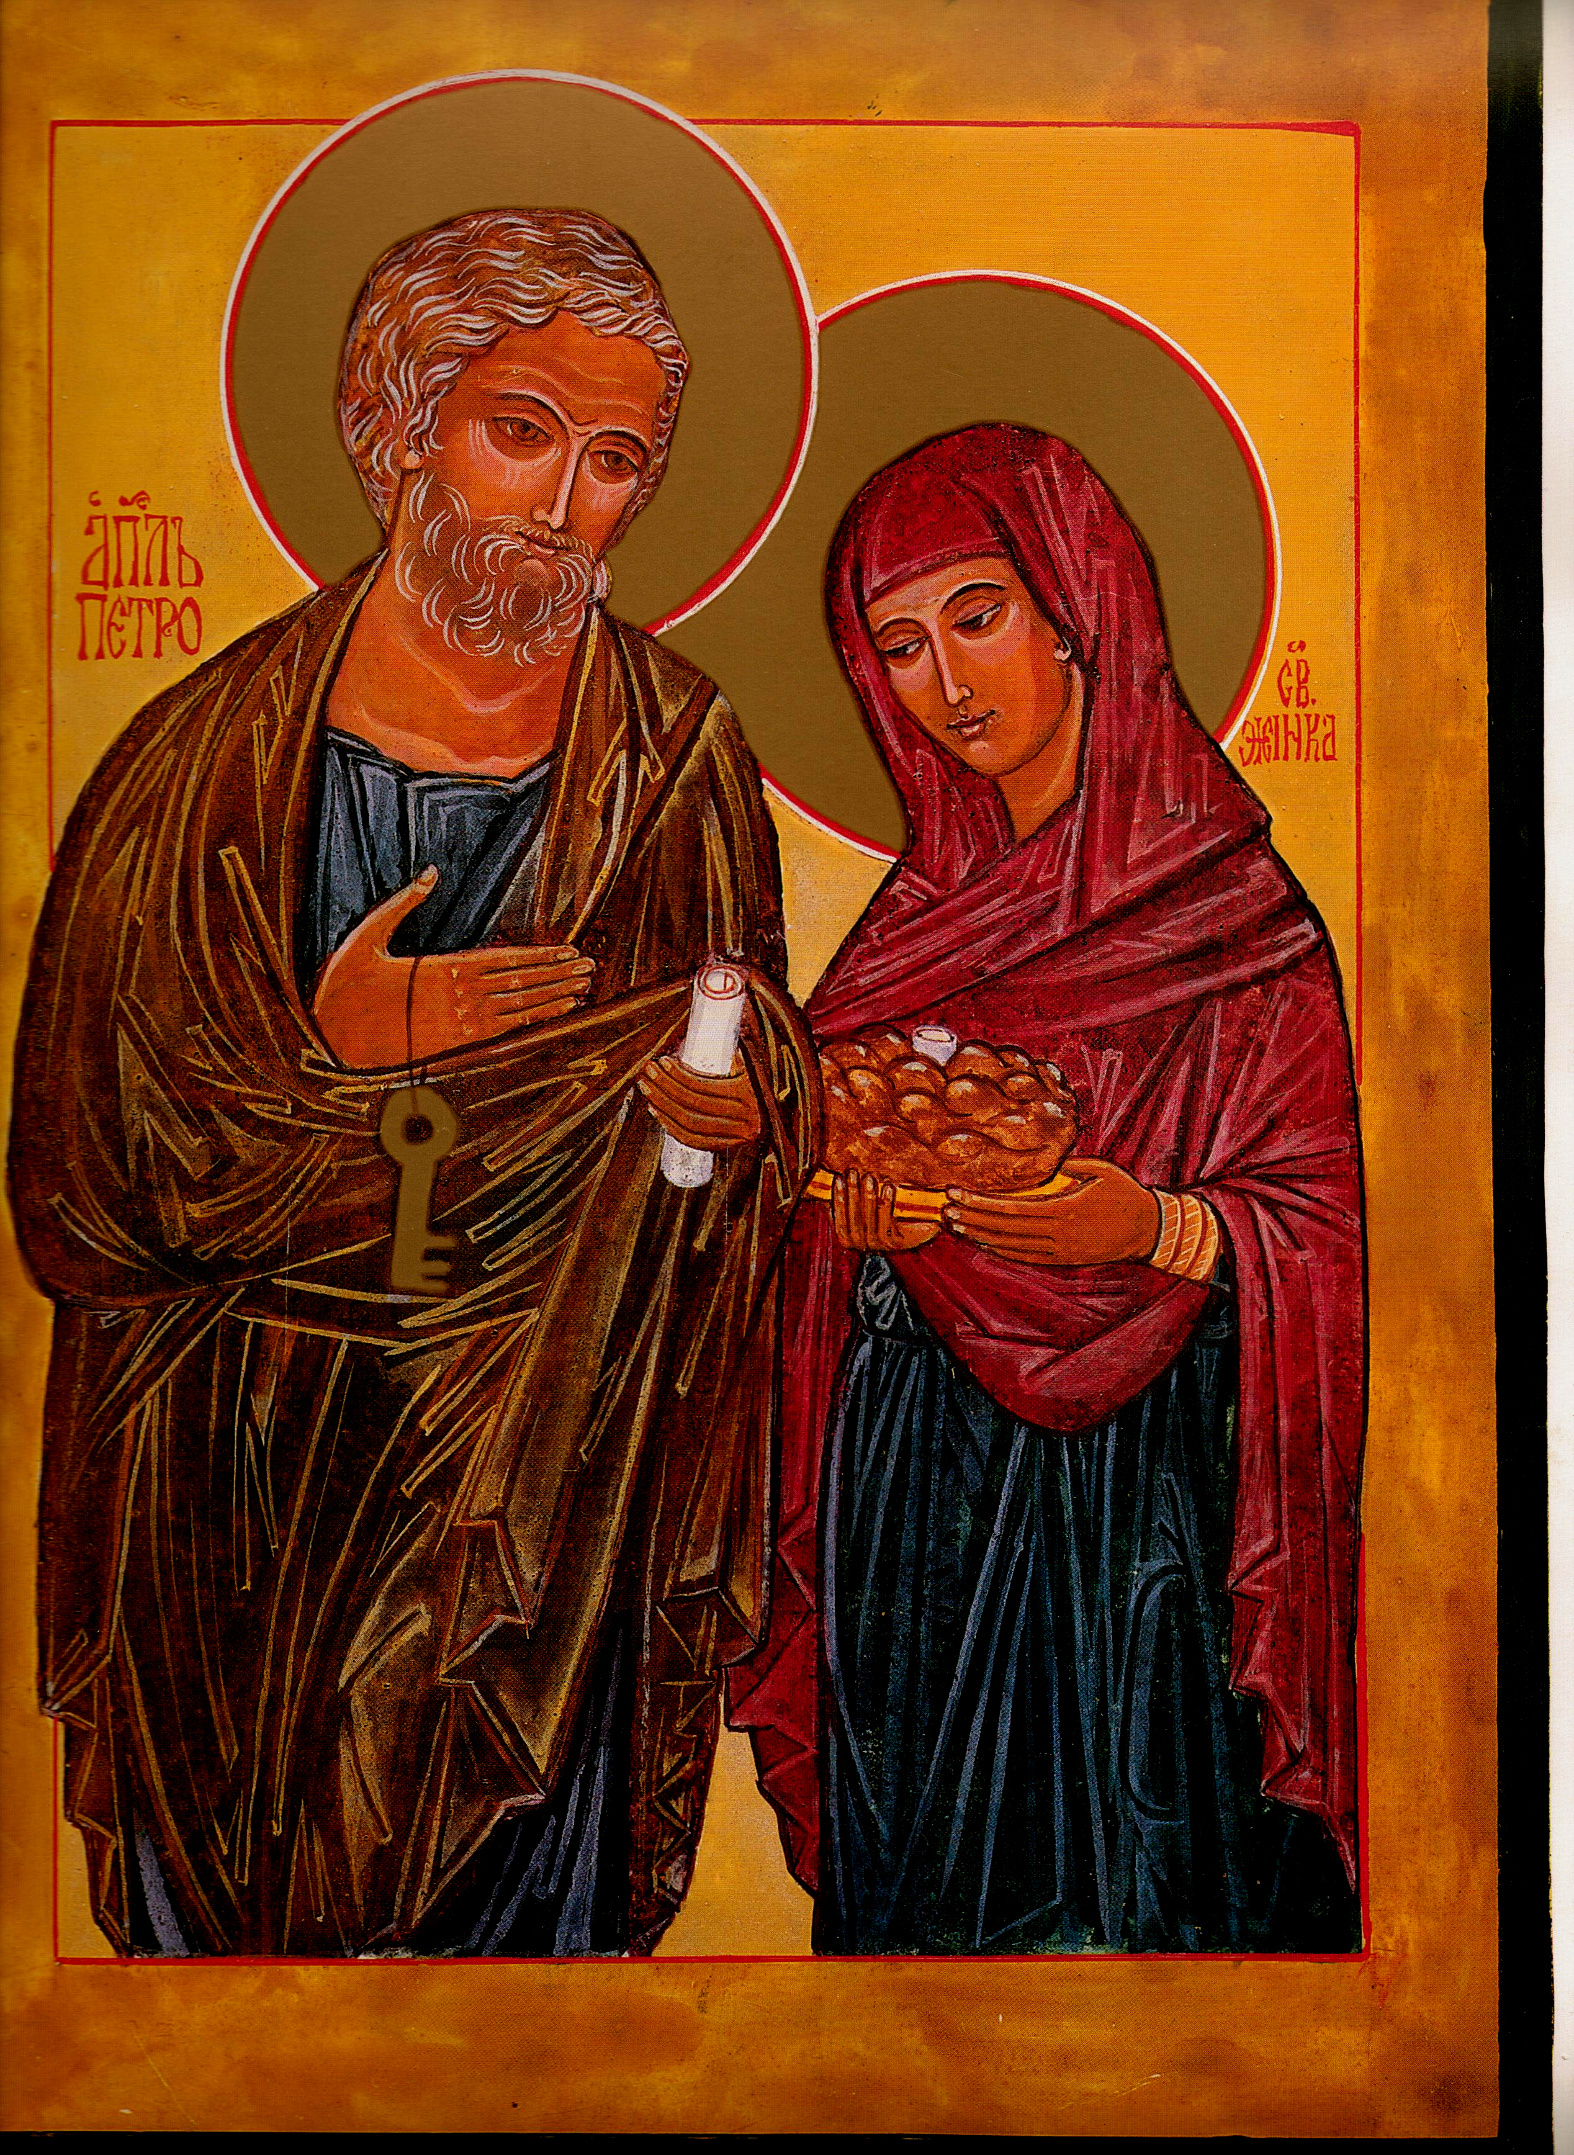

Chair Secretary

Mike Kerrigan Chris McDonnell
34 Bideford Gardens 1 High Chase Rise
Whitley Bay Little Haywood Staffs
NE26 1QP ST18 0TY

01 912 595 141 01 889 881 514

07970 86 85 57 07927 90 25 26
mkerrigan12@yahoo.com chris@mcdonnell83.freeserve.co.uk

St Peter & his wife: Eileen McCabe NYC: with permission

Member ‘s Newsletter: February 2016

Chair- Mike Kerrigan
The cause of a married priesthood continues to make progress, at least among the laity and ordinary clergy: by far the greater part of the considerable amount of recent correspondence in the Catholic press urges change and most Catholics we meet are in favour - even many who are otherwise religiously conservative. All are acutely aware of the drastic decline in priest numbers and the consequent threat of 'Eucharistic famine', but many also mention the enrichment which married men, with experience of family and secular work, would bring to our clergy. As our emeritus Chair, Michael Winter, put it: the argument is already won - what is needed now is practical contingency planning for a change which, albeit necessary and desirable, will present many practical challenges. For this reason, MMaC will, in the coming year, urge the setting up of a Commission to examine the whole issue - including a proper consultation of the laity.

But, you will say, how can you claim 'progress' when our Bishops' Conference has just rejected the ordination of married men? Well, it was progress that the issue was even debated, thanks to a courageous initiative of Bishop Séamus Cunningham; progress too that he did this in response to his own priests' request that he raise the subject; signal progress, finally, that he promptly and openly communicated to his own people and local press - and hence to the national Catholic community - a decision about which we would otherwise have remained unaware. Even if it was inevitable that the current hierarchy, mostly appointed under the constraints of the previous two pontificates, would shy away from Francis' call for bold and imaginative suggestions, nevertheless the issue is now 'on the table' - and we must maintain our efforts to keep it there.

I know that several MMaC members have contributed to the press debate (and, incidentally, our Secretary Chris now has a regular column in the Catholic Times). Thank you for that. Another priority for the coming year is encouraging MMaC action at a local level. It may be no coincidence that it was the Bishop of Hexham and Newcastle who took the issue to his fellow bishops and that MMaC has an active local group, including priests, in this diocese. If members could establish similar local groups in other dioceses, perhaps our influence could become even stronger. I'd be happy to share our experience in the north with any members who would like to do so.

Secretary- Chris McDonnell.
More and more in recent months the profile of MMaC has come to prominence through the interest of the media. We have tried to respond to the issue of celibacy whenever there has been opportunity, either through articles or letters commentating on news. It is encouraging to see that we are not alone in making such a response. For many, the argument is already won. I would ask that you encourage friends who are in sympathy with our Mission Statement to join MMaC, for not only does that give us a wider voice, but also helps with the costs of the Movement, postage, travel etc.
I will continue to respond to requests from the media when asked and to supply copies of appropriate papers as background information. We have also made contact with the international federation of married priests and a representative from that group, Joe Mulrooney, attended our last meeting

Treasurer-Bob Hughes
Our current balance stands at just under £3,050
Subscriptions are now due £15 per person/married couple. £8 for those retired. A religious community can have community membership at £15, provided we receive a list of individual members. Payment should be made directly to the Treasurer at 11 Lawrence Leys BLOXHAM Nr. Banbury OXON OX15 4NU

Website up-date
Our website continues to attract visitors, with peaks seeming to coincide with significant events in the Church (eg the bishops' recent decision rejecting married priests). Although the site is better than it used to be, it is still somewhat primitive and would benefit from management by someone more skilful than the present manager (the Chair!). If anyone would be prepared to take over this responsibility, please let us know. Meanwhile, do continue to visit www.marriedclergy.co.uk for all the latest news...
It is incidentally providing a useful information point for the media to garner information.

Annual General Meeting
We have a problem and seek your advice. Our last three AGMs have been very poorly attended. We moved away from a mid-week evening in London to York last year on a Saturday when Tom O’Loughlin addressed us. It was a first class presentation but with only a handful of listeners, in spite of extensive publicity. Such gatherings are also expensive. It is hard to justify using our small funds for something that has little response. How might we better organise an AGM? Make it bi-annual? Make it email based, with a discussion of issues etc spread over a week of email exchange? But then some might not have email access and so feel excluded. Your views would be most grateful received as soon as possible, for decisions have to be made regarding the 2016 AGM

E-mail addresses
If you do have an email address could you please let your Secretary have it: email me at: chris@mcdonnell83.freeserve.co.uk as soon as possible.

Papers available
From Michael Winter: a survey of Anglican Clergy after movement to Rome
This paper was given at the Tablet 175th anniversary in Durham.
From Mike Kerrigan: a discussion paper on viri probati availability, which we were hoping to have published in the Tablet, but no luck so far.
Please contact the Secretary if you would like copies-posted or emailed.

Establishment of a Commission of Enquiry
We have tried in so many ways to open a realistic discussion with our bishops, but to no avail. You will have seen from press reports that at the November 2015 gathering of the hierarchy, +Seamus Cunningham raised the matter but any change was rejected.
We are currently putting a package together to send to each diocesan bishop with the intention of seeking the establishment of a Commission
for England and Wales to examine the complexity of the issue. This would offer opportunity for both priests and laity to make a considered contribution to a debate that is demanding to be heard for the sake of the Church.
We would ask you to raise a similar request through your parishes, diocesan meetings, associations, to support this request.
The public silence of the hierarchy in response to recent letters and articles on this issue is a matter of concern. This is a burning issue which demands courageous conversations and a conversation is not possible unless there is an engaged response. Without such an engagement, a significant and valid outcome is not possible.

Catholic Times
Mike Kerrigan has kindly mentioned my weekly column in the Catholic Times. I must make it clear that I write there as an individual, not as Secretary of MMaC, although I have of coursed discussed the issue of celibacy on a couple of occasions. I hope you enjoy the read.

Outreach to groups
MMaC has offered to speak to local groups such as the Newman and ACTA on the issue of celibacy. This is an important way of communicating directly with local groups who maybe interested in supporting our aims. The talks given so far have been well received and with three more due in the coming weeks it is proving a valuable initiative. If you have a local parish or diocesan group that might be interested, do get in touch.
Why not consider forming your own local MMaC group as a way of keeping in touch with a national movement?

Chris McDonnell
Secretary MMaC
February 2016

