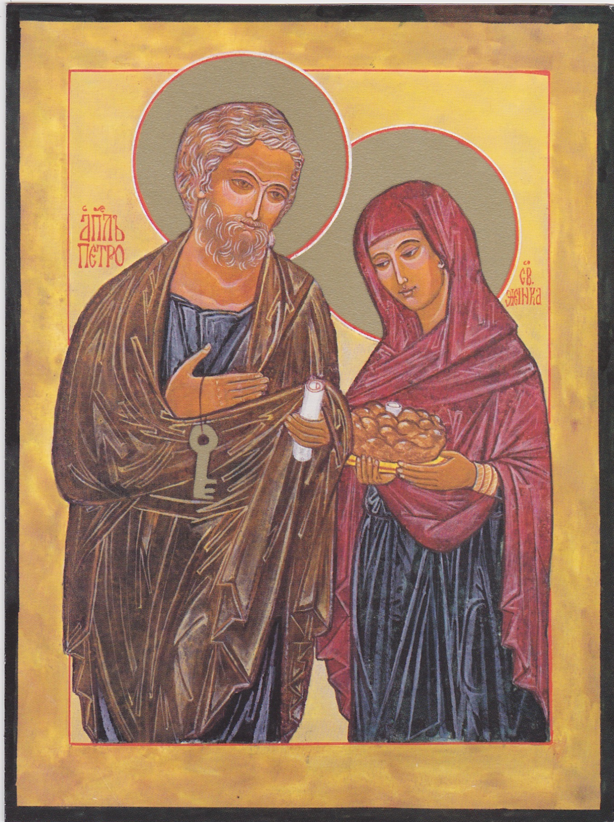

Icon of Saint Peter and his wife

“Jesus then went to Peter’s house and found Peter’s mother-in-law in bed with fever. So he took her by
the hand; the fever left her and she got up and attended to their needs.” (Matthew 8:14-15)

In this icon, Peter is shown with a key, symbol of authority, and a scroll representing his position as teacher. His wife holds bread and salt, symbols of hospitality.

The translation of the lettering is: Apostle Peter and Holy Spouse.

This icon was painted, in the tradition of Russian icons, by the American artist Eileen McCabe, who has kindly given the Movement for Married Clergy permission to use it in our publications.

