Letter to The Tablet, April-May 2021

08 April 2021
Lay vocation
F. Mary Simpson (Letters, 27 March) is bewildered by the debate about the role of women in the Church. Perhaps I can help.
The place in the body of Christ we all “strive for” is the one where the talents we have are best used. It’s wonderful to hear about women who’ve been able to realise their vocation through grassroots lay organisations, but this misses the point. Questioning Catholic women aren’t looking for rank or positions of power within the current system. We’ve had enough of hierarchy and long for a Church that organises itself in a new way, listens and values the voices of all, allowing us to be the women and men God made us to be. Nor do we want to wait for our priests to become “old and tired” before we’re allowed to play a role in parish life, as if lay participation were some sort of second best.
Pope Francis’ ideas about synodality and the Irish bishops’ response offer a way for the whole Church to walk together into a future where all the baptised can fulfil their Christian vocation and spread God’s Kingdom. Bring it on!
Jane Crone
Clare, Suffolk

28 April 2021

Topic of the week: A countryside without priests
Further to the question raised by John C. Cotman (Letters, 10 April) regarding the removal of Sunday Mass obligation, this has already been done by the Catholic authorities for those who live in rural areas. Communities with small numbers have been quietly deprived of their priests and places of worship in recent years, usually on the grounds that no priest is now available, and that the building is not worth the costs of maintenance.
Many of these places were originally served as Mass stations by clergy from religious communities, or the secular priesthood in the days when there were not only many parish priests, but also curates, sometimes three or four in a parish.
The question of how a Catholic in such a place is to continue as a member of the faith community is simply avoided. Public transport to nearby towns no longer exists in most rural areas.
The Church of England has faced the same problem, but it has also found solutions, namely the use of non-stipendiary clergy, male and female, who work under the aegis of a professional member of the clergy, and making the management of buildings and communities a local, lay responsibility.
Is the Catholic Church prepared to ordain non-stipendiary clergy to continue the nourishment of people in rural areas, or, to finally accept that working with the Church of England offers a real opportunity to strengthen the Christian presence in an increasingly secular world, employing the scarce resources of both Churches in an integrated joint mission?
Tiernan P. MacNamara
Thornton-le-Street, North Yorkshire
28 April 2021
Women in power
I’ve been looking again at the Jesuit Fr George B. Wilson’s insightful book of 2008, Clericalism: The Death of Priesthood, in which he points out that women and married men are “just as subject to the allure of clericalism” as male celibates.
I’ve encountered abusive women working in Catholic safeguarding and in the Church of England in positions of leadership. My convent school headmistress was a real bully too. Women’s gifts, practical, intellectual and spiritual, are scandalously underused in the Catholic Church, but ordination to the priesthood wouldn’t automatically solve the problem. Over-relishing power isn’t confined to men.
Susanna Gridley
London W4
06 May 2021
Too few priests
Tiernan MacNamara’s suggestions (Letters, 1 May) about how the Catholic Church might cope with a shortage of priests in rural areas are perfectly workable. I had eight Church of England churches on the edge of the Yorkshire Moors near Thirsk for 25 years, but my successors have had to cope with 11.
When holiday cover was short friends who were monks at Ampleforth would step in and take Book of Common Prayer matins. We also had open doors to any Catholics wanting to join us for Communion, especially where there were mixed marriages. There were retired priests available as well, and the churchwarden would read the daily office if no priest was available.
Previously, when I was a curate, the local Catholic parish priest and I had pushed the boundaries. We shared the hospital visit: I would celebrate a shortened Communion in the ward for all to share as they would. He either administered my chalice or communicated his own with his reserved sacrament. We got along well, though his higher authority did not like it, mostly for theological reasons totally lost on any participants. In his absence I communicated all who would, as he did in my absence.
Needs must accelerate our co-operation without too many caveats. Closed churches stand for failure, but a living presence of either persuasion will encourage folk to come for spiritual refreshment and to hear the Word broken for them, to enable them to lead better lives and understand their scriptures better.
(Revd) Toddy Hoare
Holton, Oxfordshire
13 May 2021
Worker priests
Tiernan P. MacNamara (Letters, 1 May) is right to raise the concern of those in our rural communities who cannot get to Mass. It is a question I first encountered as a school chaplain in France in the early 1990s, when in a rural boarding school with no Sunday buses.
But those were the days of hoped-for reforms. I worked with a team of priests who authorised many lay men and women to lead and preach at Eucharistic services in tiny parish churches and in the school. France had the model of worker priests – those who had a job and also celebrated Sunday Mass, and lay men and women with authorisation to ministry of various degrees.
These are questions I hope the synods being called in the UK, Ireland and Germany will address. Liverpool has already begun these discussions in our own Root and Branch synod. We need lay people and clergy to engage with these questions urgently, before the Church loses more people in this Eucharistic famine.
KATHARINE SALMON
SHEFFIELD
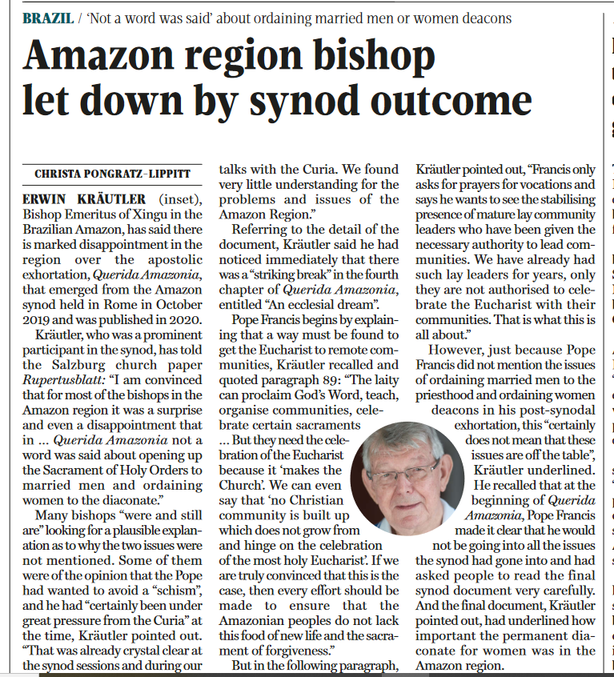
20 May 2021, The Tablet

Topic of the week: Amazon marriages of inconvenience
BISHOP EMERITUS Erwin Kräutler, of the Amazonian province of Xingu (Church in the World, 15 May), seems to have omitted to mention a point which Pope Francis stresses in Let us Dream.
Pope Francis called the synod to find out what was happening in the Amazon. He was not best pleased to find that the dearth of access to the sacraments was mainly fuelled by the reluctance of the clergy to minister to the communities in the Amazon. Apparently, they would far rather be sent on “mission” to Europe. He also found out there were few permanent deacons coming forward to be ordained.
I can well understand why Pope Francis might not be happy with clergy supporting the delegation of the more onerous aspects of their duties to lay people or women as a way of avoiding the need to minister to this beleaguered region. Perhaps it would put them in an uncomfortable position with the powerful men in the capitals who are exploiting the rainforests and their people, but who, perhaps, support the Church very generously.
I am heartened by Pope Francis’ pragmatic approach. He is open to dialogue and is comfortable with the patience and uncertainty involved, which does not lend itself to soundbite journalism. He encourages people to say what is in our hearts.
But speaking the truth as we see it is only one part of the process. He is responsible for taking this into prayer and to the Magisterium to discern how the needs of the Church can be met, without denying the truths of our faith and tradition.
Perhaps we need to take a leaf from Pope Francis’ book.
CATHERINE MANGHAM
SHREWSBURY, Shropshire
YOU REPORT Emeritus Bishop Kräutler as expressing the sadness of most of the bishops of the Amazon that Pope Francis failed to accept their plea to ordain married men. He suggests that this is due to Francis’ fear of creating a schism in the Church because, as Cardinal Sarah and senior members of the Curia think, such a course is “The smoke of Satan”. On what grounds?
Jesus three times told Peter, a married man, to feed the flock. Pope Francis is surely wrong, as a successor of Peter, if he does not remind clerics that failure to obey this command of Christ is a serious act of disobedience. If they fail to heed this reprimand, would not the Church be better off without such men, however senior they may be?
ELIZABETH PRICE
MAIDSTONE, KENT
27 May 2021
Time for equality
Christa Pongratz-Lippitt makes lucid use of the statements of Erwin Kräutler, Bishop Emeritus of Xingu in the Brazilian Amazon, to lay it out straight that unless the Church opens up the priesthood to married men and to women, it will self-destruct (Church in the World, 15 May). As Eamon Duffy said, quoted by Christopher Lamb (View from Rome, 15 May): “No priests, no sacraments; and no sacraments, no Church”.
The refusal of a collection of elderly celibate men to ordain women is downright sexism.
It hasn’t a theological leg to stand on, and it is depriving the Church of half the psychological, intellectual and emotional input that humanity can bring to it.
There is no time to argue with these men any longer. It is time for defiance, the same sort of defiance the Suffragette movement used a century ago. Only Parliament could give women the vote; only the hierarchy can extend ordination to women because only bishops can ordain. Just as male MPs and their reactionary supporters at that time had to be resisted in all sorts of ways, so must the Catholic hierarchy today.
Supporters should leaflet at as many Sunday Masses as they can, especially those churches where the diocesan bishop is the celebrant; they should stand outside church doors before Sunday Masses with posters; they should stand with them either side of the altar; deputations should go to every bishop, they should do whatever they can to get noticed by the media. A national conference should be organised at which national and local actions are agreed.
The hierarchy will fight back with threats and exclusions and appeals for prayer and patience. They must be exposed as doing the Church grave harm, and confronted by action and denunciation till they cannot take it any longer.
“‘In Christ there is neither male or female,” says the Scripture. The time has come to make it real in our lives; and if that happened, what a burst into new life the Church would experience.
Michael Knowles
Congleton, Cheshire
One flock
Elizabeth Price suggests that the Pope should flex his papal muscles more and openly demand conservative clerics obey the Vicar of Christ and follow his reforming plans (Letters, 22 May). Perhaps she has forgotten that for many centuries we have had popes who demanded that those who had less faith in the system must nevertheless obey. The result was many feeling alienated and cut off from their own Church.
Is it right that those who fear change must now feel this same alienation? Pope Francis must tend to the whole flock, conservative and liberal alike.
Francis wants a Church for everyone, even those he disagrees with, and he knows papal commands cannot create such a Church.
Adam Bergonzi
Birmingham

