.
Mmac

Movement for married clergy
http://www.marriedclergy.co.uk
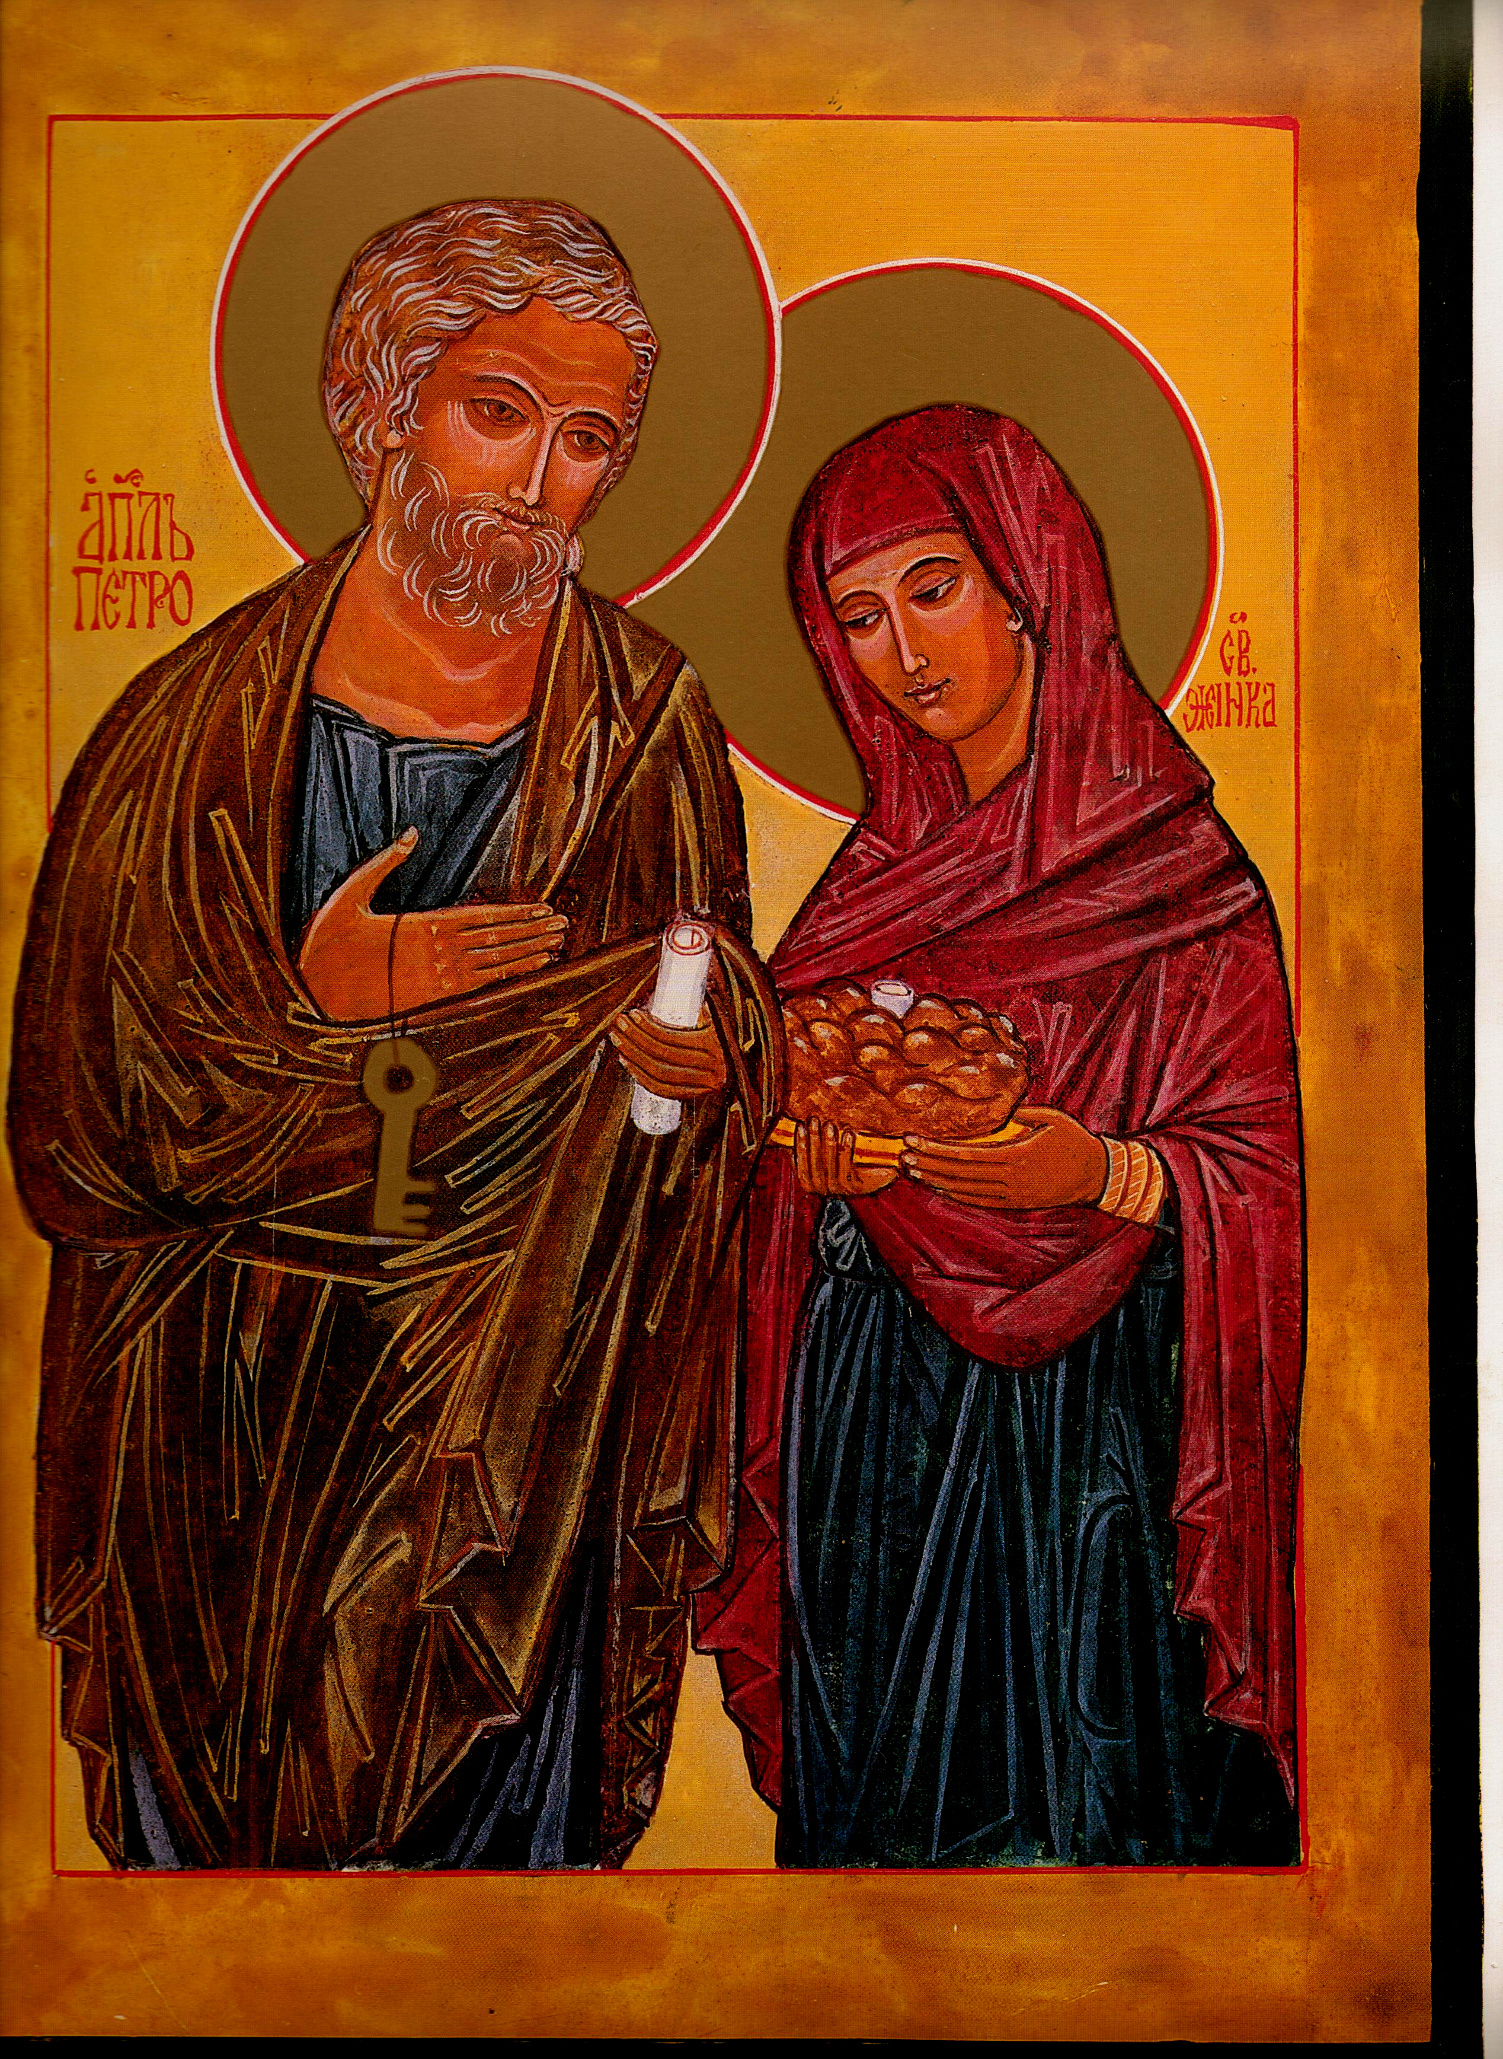

Chair Secretary

Mike Kerrigan Chris McDonnell
34 Bideford Gardens 1 High Chase Rise
Whitley Bay Little Haywood Staffs
NE26 1QP ST18 0TY

01 912 595 141 01 889 881 514

07970 86 85 57 07927 90 25 26
mkerrigan12@yahoo.com chris@mcdonnell83.freeserve.co.uk

St Peter & his wife: Eileen McCabe NYC: with permission

Member‘s Newsletter: Summer 2016

From the Chair – Mike Kerrigan

We continue to try to dialogue with our English and Welsh bishops about the need for married priests - and they (or more precisely, their leader) continue to offer us specious reasons for maintaining the discipline of celibacy: that celibacy is 'contingent' with priesthood [whatever this means]; and that we are not short of priests! Apparently, we have one of 'best' priest-to-people ratios in the world! Well, this ratio currently stands at about 1:1500 which, even if it is 'high', cannot surely be called enough. For relative to what we are used to, in terms of access to and frequency of masses, what we are faced with is most definitely a 'shortage'. To say otherwise is simply to be in denial of the facts. Moreover, as we know, parishes, which were rarely if ever small enough to be genuine eucharistic communities, are going to get even bigger. Indeed, to have proper communities where people and priest could all know each other, we need many more priests than we have ever had. The case for married priests would be still strong even if celibate vocations had maintained the level of 40 years ago.

And, of course, as MMaC takes care to say, our campaign for the abandonment of mandatory celibacy is not based solely on declining priest numbers. More fundamentally, we argue that there is simply no need to restrict ordination to celibate men, especially after Vatican II's explicit recognition that marriage is a noble state, that it and celibacy are not intrinsically linked - so that the old notion of 'cultic purity' which surely still underlies much of the resistance to change, is now fully discredited. We further argue that the God's gift of the charism of celibacy to some who seek ordination cannot be required as a universal condition for all who seek admission to the priesthood. One might even point out, citing Casti Connubii , that marriage is a basic human right which no church law can abrogate.

Still, elsewhere in Europe senior bishops do recognise the problem and have made more encouraging public statements. Archbishop Eamon Martin of Armagh says he has 'no objection' to married priests; and Archbishop Joseph De Kesel, Belgium's Primate, does not think 'we can require [celibacy] of all priests'. And there is every sign that Pope Francis' open invitation - speaking with Brazilian Bishop Kräutler - to the bishops of the world, to be 'courageous' and 'make concrete suggestions' to address the shortage of priests in their country, still stands. Even if our bishops are too timid to respond to his invitation, perhaps others will show them the way...

Is your diocese downsizing?

One after another, the dioceses of England and Wales are announcing plans to close churches and amalgamate parishes. MMaC would like to get a fuller picture of the extent of this 'downsizing'. If you are able to tell us what is happening in your diocese - or point us to sources of information - this would be most helpful. Please email, write to, or phone Chris or Mike (contact details at the head of this Newsletter).

MMaC Website

Our website (marriedclergy.co.uk) continues to post the latest news about the issue of married priests. We have a steady stream of visitors: over 40 a day on average. We're still hoping to find among our members someone who could take responsibility for managing and improving our still modest site.

From the Secretary – Chris McDonnell

Over the last few months we have focused our efforts on our approach to the Bishops in an attempt to engage in meaningful dialogue with them. As Mike has already noted we have reached an impasse. Unless conversations take place that are open and honest, we can get nowhere. Only the frustration grows. In our correspondence with the bishops – a one way route I might hasten to add – we have sought the establishment of a Commission of enquiry to examine the whole matter. But to no avail. This has been emphasised in the press coverage we have sought, the most recent being an article I have written for the Catholic Times (July 22. 2016 – Courageous outlook needed to tackle the clergy crisis. If you missed it and would like a copy, drop me an email. I have also raised the issue a number of times in my regular column Journey in Faith in the same paper. We have responded with letters to editors whenever appropriate.
Might I urge members to do likewise in support of the Movement’s mission statement? And, at the same time, write to your own bishop, state the case and seek his support when the ECCB meet. So many seem to presume that if the problem is ignored for long enough, it will go away. In one sense it will for the parish numbers will fall as the number of clergy decline with age, till there is no requirement for a Sunday Eucharist. Time tells you nothing but I told you so, wrote W H Auden.

From the Treasurer – Bob Hughes

The Current balance in our account stands at £3041.34
Subscriptions already received for this year stand at 35, together with 7 standing order.
Your subscription is now due at a rate of £15 per member (£8 if you are over 65). If a religious community is subscribing you may do so for the £15 figure provided you list the names of the community registering.
Please send your subscription direct to the Treasurer at:
11 Lawrence Leys, Bloxham nr Banbury OXON OX15 4NU

The AGM of MMAC
We have a problem. In recent years, attendance at our AGM has been abysmal. Even when we moved away from London on a Tuesday evening to York on a Saturday, there was very little response. Given the costs of arranging such a gathering, hire charges for rooms, fees for speakers, publicity and transport costs, we felt, with regret, that we would not plan a MMaC AGM this year. We approached ACTA with a view of holding a meeting at their national conference in November but, unfortunately, that proposal fell through.
We urgently need the advice and opinion of members regarding the future. Bear in mind that the AGM is the forum whereby we elect the Committee.
Would regional AGMs offer a solution in order that large distances are not involved in travel? Come back to us with some thoughts.

Parish based MMaC groups?

What is the current opinion in your parish regarding married priests? Would a local group offer a forum for discussion and development of our aims? In this way we might change the current national membership of disparate members into a more locally framed environment. ACTA have centred their activities on each diocese which has worked well. Might we learn from this?

Talks to various groups

Both Mike and I have spoken to a number of Newman Circle meetings and have further dates already in the diary for the Autumn. Is there a local group in your area that might offer us an invitation to talk?

Our recent letter to the ECCB, addressed to the Cardinal

Thank you for your letter of March 18th in response to our recent proposal sent to the bishops of England and Wales on behalf of the Movement for Married Clergy. It was considered at some length at our meeting in London on April 11th.
The Committee felt genuine disappointment with its tone and content and we would like to itemise points that have contributed to our concern.
The central proposal of our original letter was that consideration should be given to the establishing of a Commission to examine the issue of the ordination of married men as priests a spirit of mutual exchange between our bishops and the laity.

Your most recent letter included the Note from your last Plenary Assembly:
“Reflecting on pastoral need, the changing shape and character of Catholic Parishes, the sacrificial nature of priesthood and the congruency of celibacy and priesthood the bishops were clearly of a mind not to support this suggestion”.

To close the door in such an emphatic manner precludes any attempt at open discussion within the Church in England and Wales, when it is already a matter of open exchange amongst the laity, in the media and indeed amongst a considerable number of our priests.
It is precisely because we have reflected on pastoral need that we are raising the issue of the celibacy discipline with you and your brother bishops. The age profile of those currently in parish ministry is steadily advancing. Not only does this factor place extra stress on those parish priests working in the context of a single parish, but in instances where parishes are combined due to a lack of clergy, that pressure is greatly increased.

The number of men at present in our seminaries does not match the need in the coming years. Some of those presently in training will not see the course through and will leave. Others, who will be ordained, may come to experience the difficulties of celibacy early in their ministry and leave to marry. Those left will not be sufficient in number to meet our current parish needs.
It is a very evident there is a real change occurring in our Catholic parishes. It is because of this that the proposed Commission would have to attend to this matter as part of the discussion.

Of course, there is an important sacrificial aspect in vocation to the priesthood, but simply to assert that there is a “congruency” of celibacy and priesthood is inadequate and to our mind, inaccurate.
Firstly, we are at a loss to understand what precisely is meant: in ordinary language, congruent means in agreement or harmony. To say that priesthood and celibacy are congruent, without further explanation, simply begs the question. Vatican II declared that the two states are not intrinsically linked. We believe that current and impending pastoral need requires proof that celibacy is not merely congruent with priesthood, but that, despite the manifest crisis in priest supply, it is still a necessary condition.

This concern with this issue is not restricted to the Church in England and Wales. Questions are being asked across Europe and the Americas regarding the value of a disciplinary condition dating from the Lateran Council of 1139. Only last year Bishop Krautler raised the issue with Pope Francis regarding the critical circumstances in his Brazilian diocese. He was told quite clearly that he should look for a local solution rather than expect Rome to have all the answers.

It is time we engaged in courageous conversations, recognising the sincerity of the concern that we all share for the pilgrim Church here in England and Wales.

This is why we making – again - our suggestion that a Commission of Enquiry be established by the bishops where all might make a considered contribution? Of course the terms of any enquiry should be very carefully set, and taken with professional advice.

As our original letter, to which you kindly replied on behalf of your fellow bishops, was sent individually to each bishop, we have copied this extended reply to all members of the Bishops’ Conference.

Yours sincerely

Chris McDonnell Mike Kerrigan
Secretary MMaC Chair MMaC

