.
Mmac

Movement for married clergy
http://www.marriedclergy.co.uk

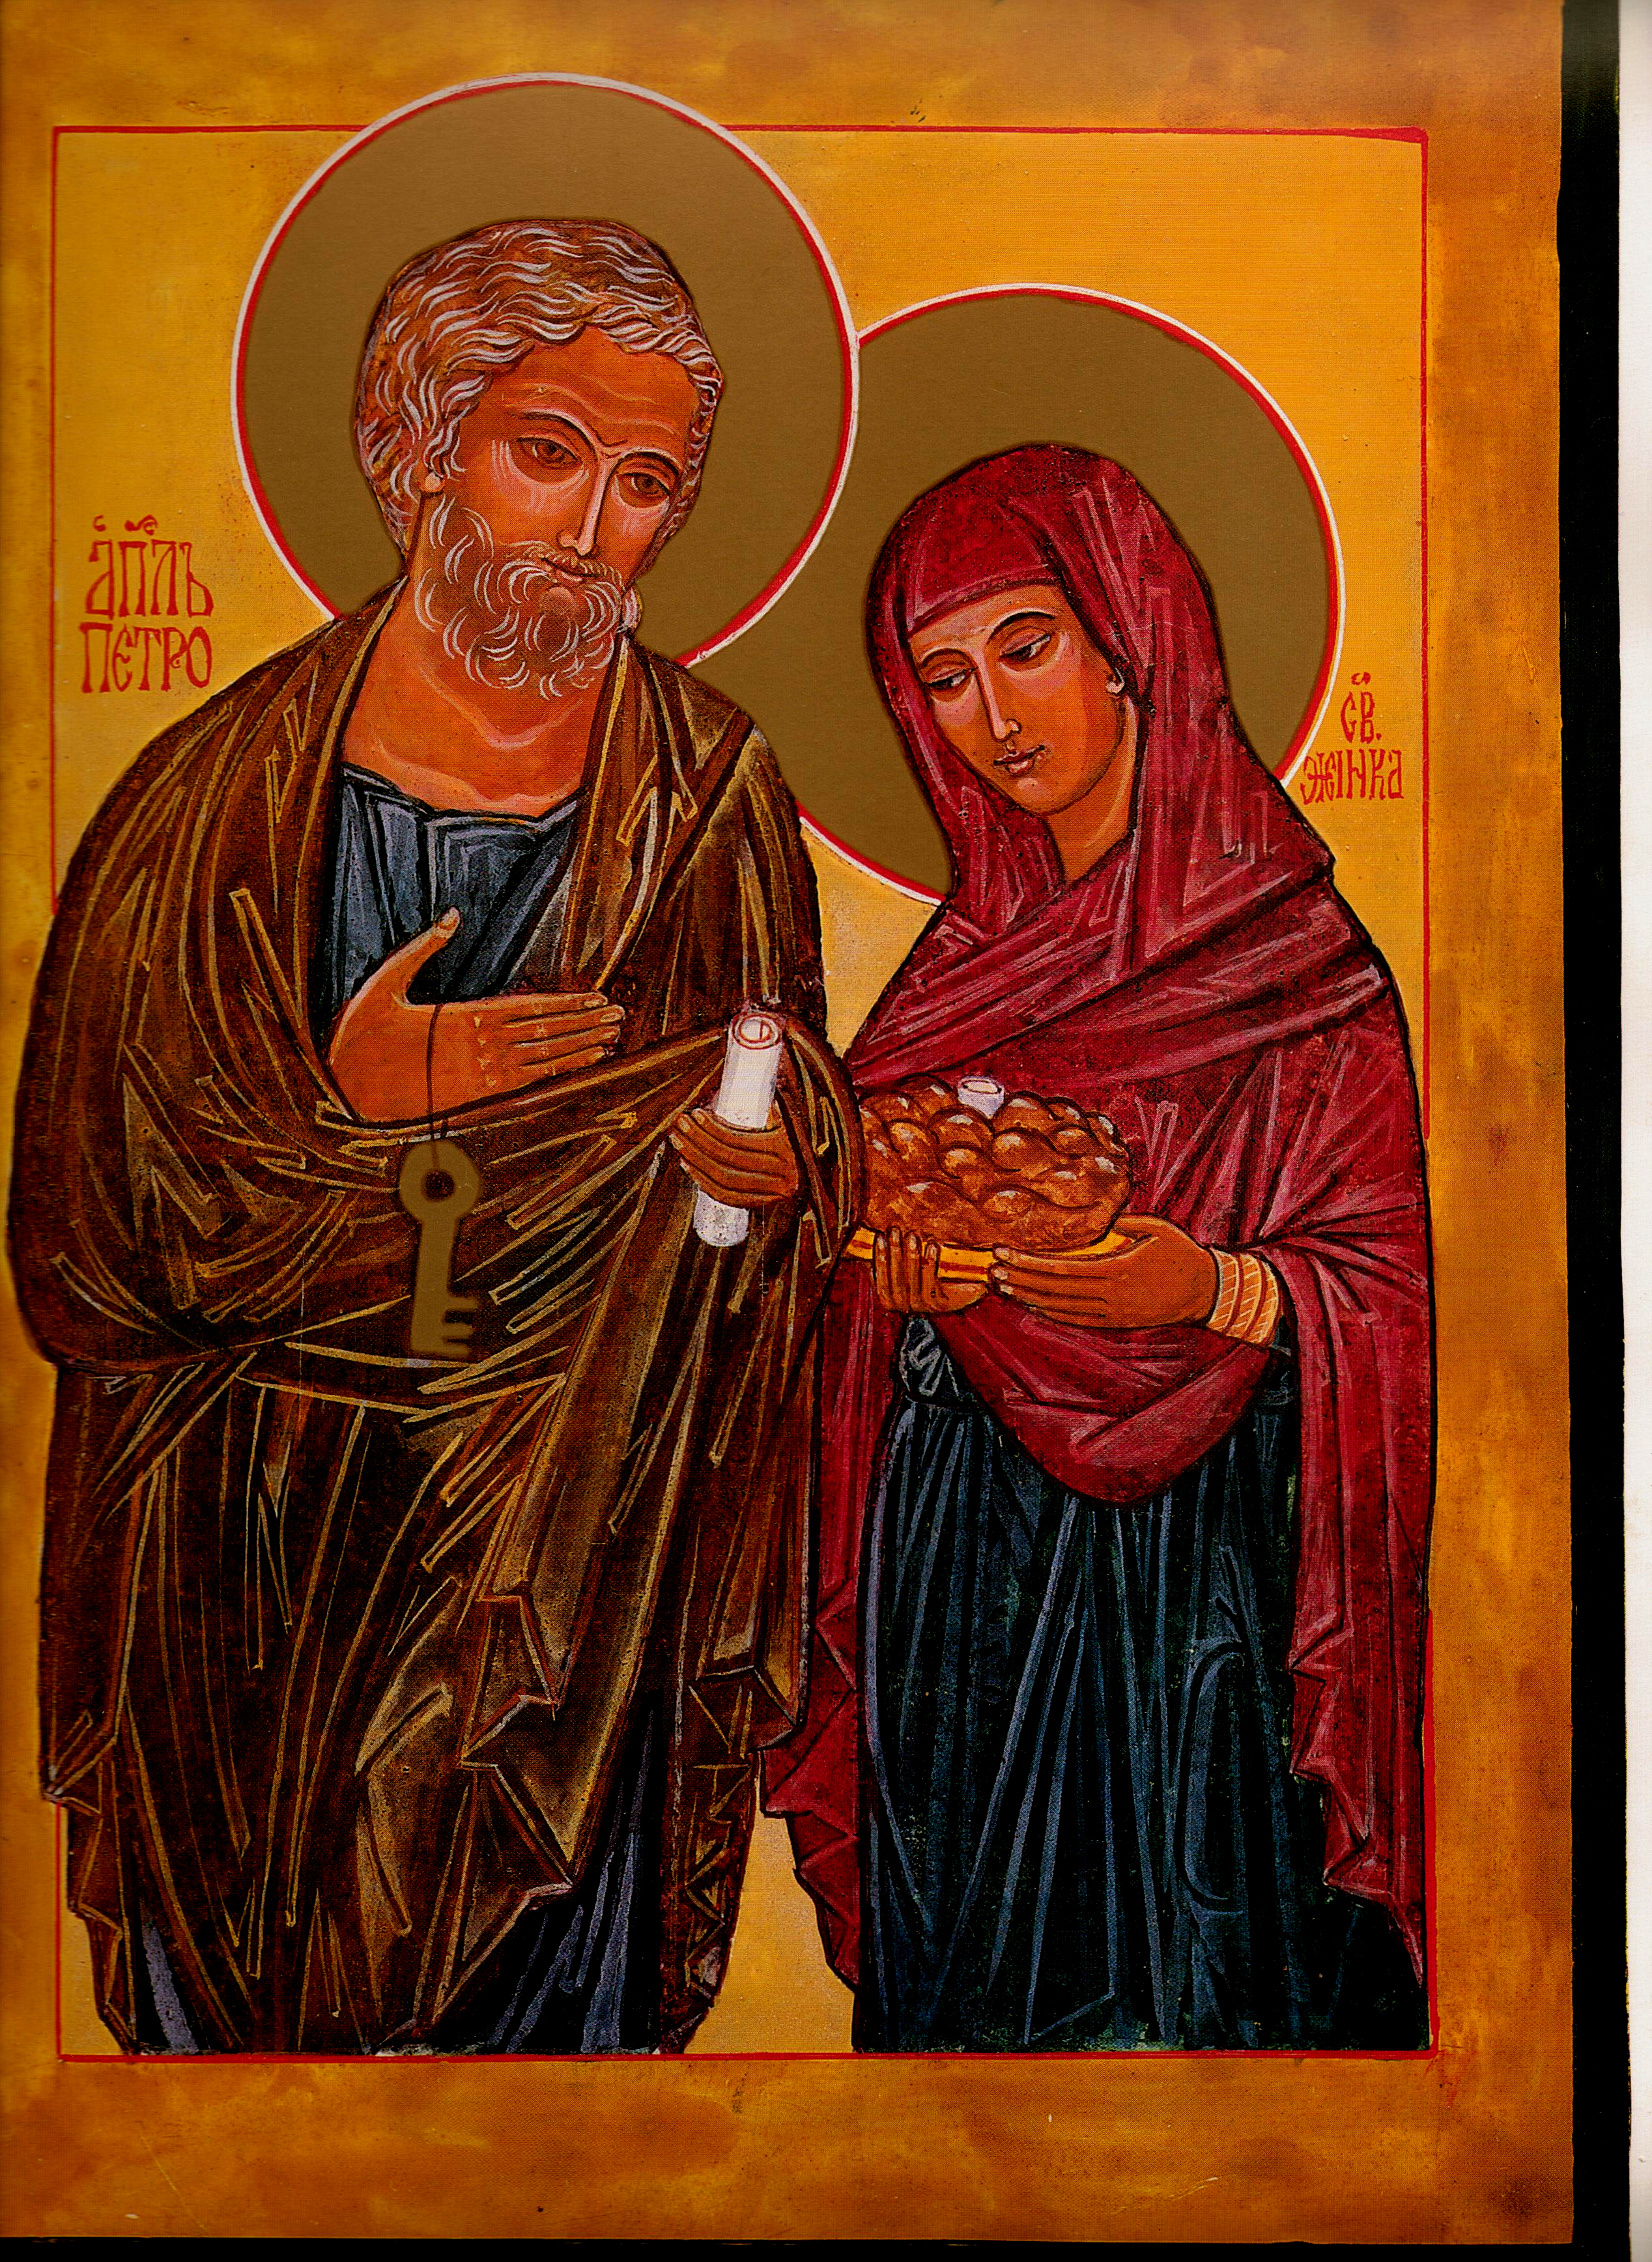

Chair Secretary

Mike Kerrigan Chris McDonnell
34 Bideford Gardens 1 High Chase Rise
Whitley Bay Little Haywood Staffs
NE26 1QP ST18 0TY

01 912 595 141 01 889 881 514

07970 86 85 57 07927 90 25 26
mkerrigan12@yahoo.com christymac733@gmail.com

St Peter & his wife: Eileen McCabe NYC: with permission

Members' Newsletter: Summer 2017

From the Chair-Mike Kerrigan
In the last Newsletter, I ended up with the phrase piano, piano, si va lontano – slowly, slowly, you’ll go far. True, the Church has usually taken ‘centuries’ to change, but the change we urge is urgent: the numbers of young men offering themselves for the celibate priesthood in England and Wales continues to dwindle. Indeed, this year, those due to begin their now eight-year journey to ordination may be in single figures: given the usual drop-out rate, it is entirely possible that no priests at all could be ordained for our 22 dioceses in 2025!
But piano can also mean gently, carefully. Have we in MMaC been too gentle in our approach to this obdurate hierarchy? Probably. So – while continuing to be courteous and professional – we decided it was time to take at least one glove off.
In April we approached the Guardian newspaper, inviting them to write about the issue of married priests. Their religion correspondent, Harriet Sherwood, interviewed MMaC secretary Chris and produced a very balanced article on April 29. This article was widely noticed and, in particular, picked up by the American National Catholic Reporter. Chris was interviewed again and, using also a substantial contribution from Bishop Crispian Hollis, their correspondent echoed the message for the USA. This article, too, has had echoes: for example, with the Association of US Catholic Priests, which also promotes the ordination of married men.
Closer to home, we sent a copy of the Guardian article to all the 48 bishops in England & Wales. We weren’t optimistic about getting a response – indeed, many in authority in the Church appear strangely discourteous, not to say unprofessional, in simply ignoring correspondence. For example, when Karl Rahner sent to the German bishops a memorandum on the same subject, only two even acknowledged it; and when, in 2010, Hans Küng wrote to every bishop in the world, not a single one ‘dared to answer’. So, when seven of our bishops did reply, some in not discouraging terms, we felt we might at last be getting somewhere! However, just the other day we got a brusque, brief reply: no change.... see quote below
MMaC Website ( www.marriedclergy.co.uk )
Our website continues to attract visitors. Indeed recently 'hits' have increased - a sign of the times? In our last Newsletter we asked for assistance with its management. Any volunteers?
e-Bulletin
If MMaC has an email address for you, you will, we hope, have received our first three 'e-Bulletins'. The purpose of these, initially at least, is to bring relevant news items and other reading directly to members' attention. The e-Bulletin consists of links to the latest news plus other useful documents to download. The latter will include handouts which we have used in our talks to groups, articles, extracts from books, etc. If you have received the e-Bulletin, we would appreciate your comments. Thank you for those who have already commented. If you'd like to receive the e-Bulletin but have not yet told us your email, then please do send it to either of the addresses at the head of this Newsletter.
Diocesan reorganisations
We are still concerned that Diocesan reorganisation is more often than not, resulting in the linking of two or more parishes under the responsibility of one priest, himself in his later years. This is not a viable solution to a growing problem.
From the Secretary-Chris McDonnell
We have continued in recent months in our attempt to open a meaningful dialogue with the Bishops of England and Wales. By and large, unsuccessfully. However an article was published in the Guardian earlier this year which Mike Kerrigan refers to. Here is an extract from that article-a full copy can be found at our website. see website News page 29/04/17
'... Catholic bishops in England and Wales are facing a fresh call for a national commission on the ordination of married men amid mounting concern that the church’s celibacy requirement is contributing to a shortage of priests.
The call for a review of celibacy as a condition of priesthood comes after Pope Francis signalled that he was open to the possibility of ordaining married men under specific conditions. The issue is expected to raised at a synod next year on vocation.
The Movement for Married Clergy (MMaC) is renewing its call for a national commission of bishops, clergy and laity to discuss ways of tackling the shortage of priests. “We’re asking bishops to recognise the issue and examine possible solutions in good faith,” said the MMaC secretary, Chris McDonnell.
A recent editorial in the Catholic Times endorsed the call. “What has the church got to lose by establishing such a commission? Or perhaps more importantly, the focus should concentrate on what the church has to gain from such a move,” it said.
“We have a very advancing age profile of serving priests, and low numbers of people going into seminaries,” said McDonnell. “At the moment, it’s just about manageable. But in five years’ time it’s going to be very different. We want to use this window of opportunity to look at what could be done.”
...... “I think the vast majority of lay Catholics would accept married clergy – particularly young people for whom it is a no-brainer,” said McDonnell. “But we want to be very clear that we’re not rejecting celibacy. If a man decides as part of his vocation to be celibate, we’d applaud his dedication. Celibacy and the priesthood should not be considered incompatible.”
Two of the church’s 22 serving bishops, Tom Burns of Menevia and Seamus Cunningham of Hexham and Newcastle, and three retired bishops have backed married priests in recent years. However, the bishops’ conference of England and Wales rejected a proposal to ordain married men in 2015.

Cardinal Vincent Nichols, archbishop of Westminster and leader of the church in England and Wales, has said he sees no need for change. “I don’t think we are in a [vocations] crisis in England and Wales.” he told the Irish Catholic in February. adding: “I personally value … the celibacy of the priesthood.”
Father Christopher Jamison of the Catholic National Office for Vocation said he had “no problem” with the ordination of married men, but “it does not solve the fundamental challenges facing churches today”. End quote.

There was also a further report on the NCR website in the US to which both +Crispian Hollis and myself contributed.

Since that article which we printed and circulated to every Bishop in the ECCB, we have received a letter from the General Secretary of the Bishop's Conference, Fr Christopher Thomas in which he says'In response to your request [for a commission that is], I can only refer you to my previous letter to you in March last year. Continuing publicity in the media does not change the normative state. The Bishop's Conference position on this matter has not changed'.

How then might we talk to each other? I would urge members to continue offering the editors of our catholic press letters of support for a Commission and further to make contact with your Bishop to express your concern at the non-productive silence. The Catholic Times has carried a number of supportive letters, including correspondence from MMaC committee member Liz Price as well as editorial for which we are grateful. On behalf of MMaC we offer our congratulations to the newly appointed editor of the Tablet, Brendan Walsh.
From the Treasurer
If you haven't done so already, please send in your subscription for this year which is now due. MMaC cannot function without sufficient funds to meet our running costs. Use the enclosed form or give to someone to encourage them to join us.
AGM 2017
This year we have arranged our AGM to coincide with a Study Day-'Changing Catholic Ministry. This study day is being jointly organised by the Movement for Married Clergy, Catholics for a Changing Church and the International Federation for a Renewed Catholic Ministry.
It is being held on Friday November 3rd in the crypt of St Ethelreda's Church, Ely Place London EC1N 6RY, starting at 10am and concluding at 5pm. The nearest underground stations are Chancery Lane and Farringdon. . Our speakers include

Joe Fitzpatrick is a Scot who lives in Yorkshire, a former Inspector of Schools and a Catholic priest of the diocese of Motherwell who resigned his public ministry in order to be able to marry.
Bridie Stringer is Lecturer in Pastoral Theology at St Mary's University Twickenham. In 2013 she published Baptising Babies and Clearing Gutters: A Fresh Appraisal of the Permanent Diaconate.
Anthony Padovano, American thologian, holds doctorates and professorships in theology and literature. He is the author of twenty-nine books including three award-winning plays, translated into nine languages. He has been visiting professor at twenty-five American colleges and universities, lectures world-wide and appears regularly in the media on both sides of the Atlantic.

Programme for the Day:
- 10.00 registration and coffee
- 10.30 welcome, announcements, first speaker followed by discussion/questions
- 11.45 break
- 12.00 second speaker followed by discussion/questions
- 13.00 lunch break
- 14.00 separate meetings for IFRCM and MMaC
- 16.00 third speaker and summing up discussion
- 17.00 finish
There is no charge but participants are asked to bring some lunch to share with others.

Broken- The recent Television series centred on a Parish Priest's experience in Liverpool, written by Jimmy McGovern, has received wide acclaim. It is still available on iPlayer. Bishop Hollis says it should be compulsory viewing for all clerics!
Chris McDonnell MMaC Secretary, July 2017

