11 September 2019, The Tablet

German bishops at loggerheads over plan for church renewal
by Christa Pongratz-Lippitt

Woelki said he believed the new synodal procedure 'holds great dangers – above all the danger of splitting the the German Church'

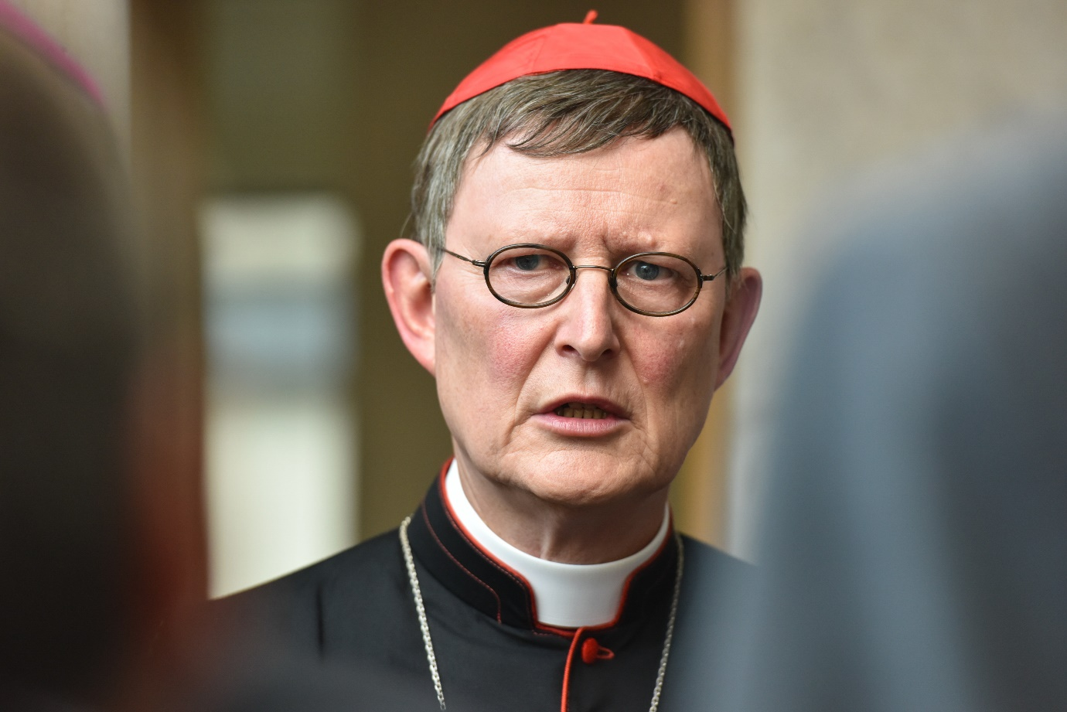
Cardinal Rainer Maria Woelki of Cologne is pictured in Limburg, Germany, Sept. 18, 2016
Photo: CNS photo/Harald Oppitz, KNA
The German bishops are at odds over the “binding synodal procedure” they decided to adopt at their plenary in March this year, designed to reduce clerical power and address clerical sexual abuse and the celibacy rule.
On 29 August the bishops’ conference confirmed that four forums ( “Power, Participation and Checks and Balances”, “The Priestly Mode of Life”, “Sexual Morality” and “Women in Church Service and in Church Offices”) would be led by a bishop and a lay Catholic.
However, on his return from a visit to the United States, Cardinal Rainer Maria Woelki of Cologne warned that the synodal procedure could put community with the World Church at stake and split the German Church.
In an interview in the Cologne Kirchenzeitung, he said he was “sceptical” about the procedure, fearing that “it holds great dangers – above all the danger of splitting the the German Church”. In his letter to the German Catholics in June, Pope Francis had especially asked the German Church to remain in union with the World Church and with the Catholic faith, he recalled. Catholic Churches in the US were grappling with the same problems as the German Church, but he had the impression that the answers they had arrived at were “not attempting to go it alone”.
The Bishop of Mainz, Peter Kohlgraf has defended the synodal procedure. At a celebration for lay pastoral assistants in Mainz Cathedral, where the synodal procedure meetings are to be held, he recalled that the procedure had not been decided on “for fun but against the background of terrible crimes” committed by priests.
Meanwhile conference president Cardinal Reinhard Marx told the Frankfurter Allgemeine Sonntagszeitung on 8 September that a “regional relaxation of the celibacy rule” was conceivable. He could “well imagine that a conclusion could be reached that it was reasonable – in certain regions and under certain circumstances – to allow married priests”, he replied when asked whether he thought such a reform might be concluded at the coming Amazon Synod in Rome in October. “This does not mean, however, that we [in Germany] can solve our problems via the Amazon Region,” he added. Asked for his opinion on women’s ordination, Marx said he was not necessarily against it but could not see how one could shelve what Pope St John Paul II had declared as final in 1994, namely that the Church had no authority to ordain women. Nonetheless, the question could still be discussed: “As I said to Pope Francis, ‘Holy Father, the discussion is not over’,” Marx said.

15 September 2019, The Tablet

Marx defends German synodal procedure against Vatican criticism
by Christa Pongratz-Lippitt

Marx also insists unequivocally that the German bishops have the right to debate matters on which the Magisterium has already ruled

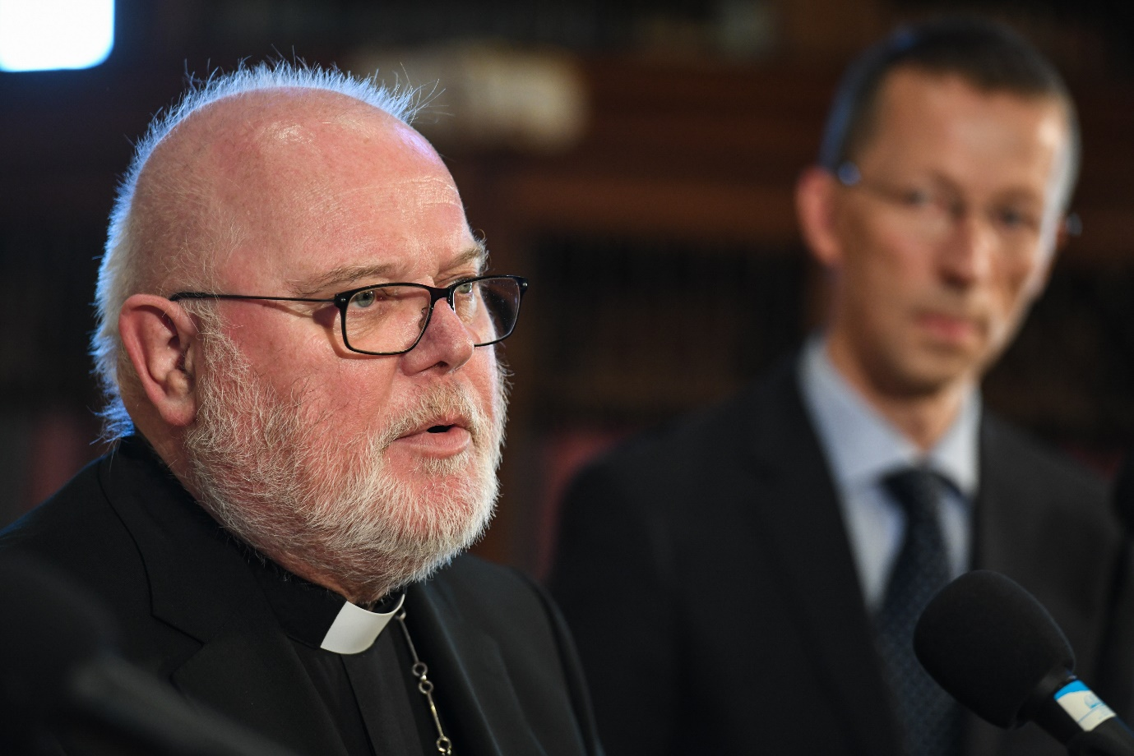
Cardinal Reinhard Marx of Munich and Freising, president of the German bishops' conference, speaks to the press at the beginning of the German bishops' fall assembly in Fulda, Germany, Sept. 24, 2018
Photo: CNS photo/KNA
Cardinal Reinhard Marx has staunchly defended the “synodal procedure” the German bishops have initiated together with the Central Committee of German (lay) Catholics against attempts by Rome to question its canonical legality, according to a 14 September report in the German daily Frankfurter Allgemeine Zeitung, which claims to have exclusive possession of Marx’s letter. He also insists unequivocally that the German bishops have the right to debate matters on which the Magisterium has already ruled.
Marx was replying to a letter by the Prefect of the Congregation for Bishops, Cardinal Marc Ouellet of 4 September and the attached assessment from the Pontifical Council for Legislative Texts, which accused the draft of the two-year “synodal procedure” which the German bishops’ plan to hold together with Central Committee of German (lay) Catholics” of violating canonical norms.
In his reply to Ouellet, Marx suggests that it would have been “more helpful” if the Vatican had sought an exchange with the German bishops “before sending out documents”.
He repudiates the Vatican’s accusation that the German bishops were de facto holding a synod without actually calling it a synod and were therefore violating canon law. Such accusations were unfounded, he said. “They (the Vatican authorities) know from our protocols” that the (German) bishops would not deliberately have chosen a form for their consultations that could have been accused of being against church law. The “synodal procedure” was a sui generis procedure and therefore the statutes should not be seen “through the lenses of canon law instruments.”
The Vatican accusations, moreover, referred to a draft that had long since been revised, Marx pointed out. At its coming plenary in the last week of September, the German bishops’ conference would vote on (“synodal procedure”) statutes that would do justice to the “particular responsibility” of the bishops,which Rome was concerned about.
In any case, Marx underlined, no resolution would be able to bind a bishop. “Maybe there will be resolutions which are addressed to the bishops’ conference or to the bishops who will then make the appropriate decision as to how such resolutions are to be dealt with”. If it was a case of questions that must be decided by the Universal Church, they would be forwarded to the Pope.
“We hope that the results of the formation of an opinion in our country will be helpful for the World Church and in certain cases for other bishops’ conferences. I, in any case, cannot see why questions on which the Magisterium has ruled should be barred from any debate – as your letter suggests”.
The suspicion on Rome’s part that by discussing such subjects as power, women’s position in the Church, sexual morality and the priestly way of life, the German bishops were ignoring their true calling as shepherds was unacceptable, the cardinal said. “We bishops are doing what we are committed to as shepherds in order to liberate evangelisation and proclamation of Christ’s Message from the obstacles which stand in the way.”

17 September 2019, The Tablet

German Church stands its ground on its ‘synodal procedure’
by Christa Pongratz-Lippitt

'We realise our approach to the entire procedure must be based on the primacy of evangelisation'

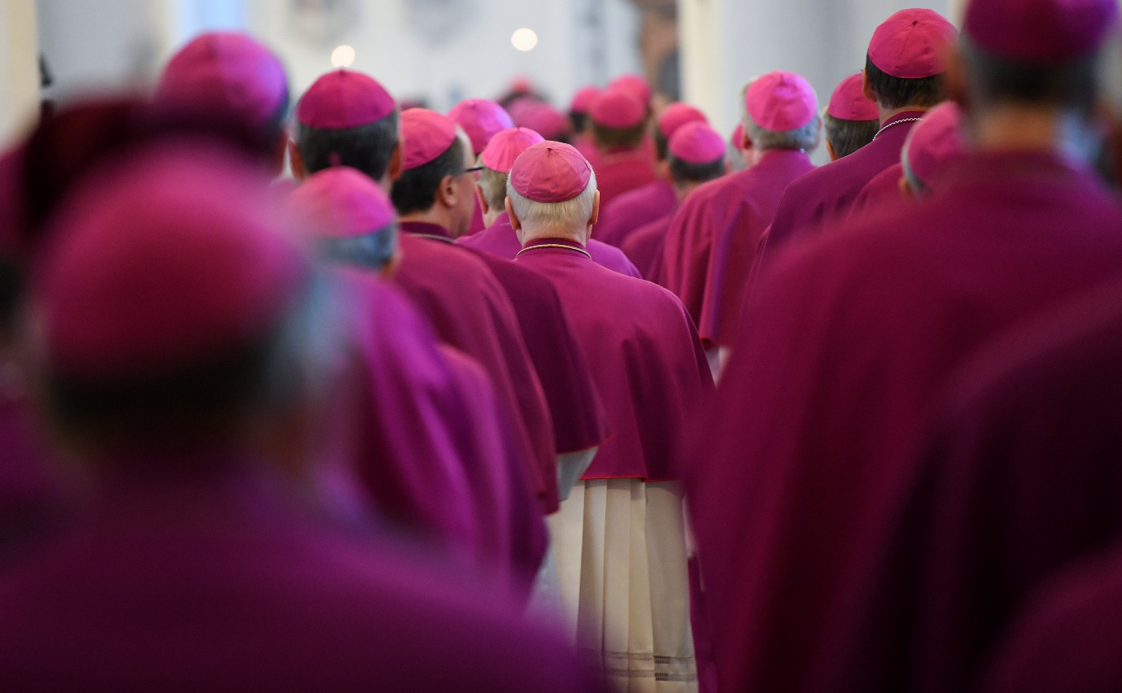
Members of the German Bishops' Conference pictured at the opening service of the September 2018 Plenary Assembly of the German Bishops' Conference
Photo: Arne Dedert/DPA/PA Images
The German bishops and lay Catholics made it quite clear last week that they are determined to find a way through the abuse crisis which has shattered the Church’s credibility, led to a mass exodus from the German Church and is the greatest obstacle to evangelisation. They did this in the face of warnings from the Vatican that the “synodal procedure” for church renewal which they are planning and the precise role the laity is playing are endangering church unity and possibly run counter to canon law.
Leading representatives of the bishops’ conference and the Central Committee of German (lay) Catholics (ZdK), which represents several million German Catholics, who met for two days at Fulda from 13-14 September to discuss further plans for the “synodal procedure”, decided to reply to Pope Francis’ letter of 29 June addressed to “The Itinerant People of God in Germany”. In it, Francis praised German Catholics’ commitment and their efforts at church reform but also warned them to remain in union with the World Church. The primary concern of church renewal must always be evangelisation, Francis had emphasised.
In their letter of 14 September, the participants at the Fulda meeting assure the Pope that they have studied what he said in his letter carefully. “We realise our approach to the entire procedure must be based on the primacy of evangelisation. We are determined that the synodal procedure will be a ‘spiritual process’ [and] we, too, have our eyes both on unity with the World Church and on the local situation here,” the letter says.
The ZdK president Thomas Sternberg recalled that the German Church’s abuse study of 2018 had shown that there were systemic problems in the German Church which fostered abuse and “obscured the credible proclamation of the Gospel Message.”
The statutes of the “synodal procedure” were discussed at the Fulda meeting but are not yet published. They are the basis of the consultations at the coming bishops’ conference plenary from 23-26 September and of the next ZdK meeting. Both the bishops’ conference and the ZdK must agree on the statutes before the “synodal procedure” begins as planned at the beginning of December.
The working papers on the four forums that will be discussing “power and checks and balances”, “sexual morality”, “the priestly lifestyle” and “women’s place in the Church” at the two-year “synodal procedure”, have now been published. The forum dealing with women’s place in the Church has been marked “of utmost urgency”. It is considered the acid test of whether the Church’s desire for reform is really authentic, the participants at the Fulda meeting said. The question of women’s ordination has, however, been excluded.
A 4 September letter by the Prefect of the Congregation for Bishops, Cardinal Marc Ouellet with an attached “assessment” from the Pontifical Council for Legislative Texts has come in for particularly harsh criticism from the President of the German Bishops’ Conference, Cardinal Reinhard Marx. The letter accused the draft of the two-year “synodal procedure” of violating canonical norms.
“We hope that the results of the formation of an opinion in our country will be helpful for the World Church and in certain cases for other bishops’ conferences. I, in any case, cannot see why questions on which the Magisterium has ruled should be barred from any debate – as your letter suggests,” Marx wrote, according to a report in the Frankfurter Allgemeine Zeitung, which claimed to have exclusive sight of Marx’s letter.
“Rome has obviously not yet understood in quite how great a crisis the Catholic Church, not only in Germany but worldwide, finds itself,” the vicar-general of Essen, Fr Klaus Pfeffer, told katholisch.de, the German Church’s official website. “Whoever still believes today that warnings or even threats can nip discussions in the bud won’t solve a single problem. On the contrary, they will merely make the disagreements and rifts worse.”
The editor of the German quality daily Süddeutsche Zeitung, Matthias Drobinski, one of Germany’s best-known religious correspondents who is a committed Catholic and has a degree in Catholic theology, commented on 16 September: “Whoever is still looking for proof that authoritarian clericalism is alive and well and thriving in the Catholic Church – here it is: Cardinal Ouellet’s letter, which … has the following message for his Catholic brothers and sisters in Germany: ‘If you feel you must discuss the future of your Church at all cost, then don’t think you can decide anything of significance. Basta’. Not a word about the reason that made the [synodal] procedure necessary, namely the Church’s massive loss of credibility because of the abuse scandal. Not a word about the Pope’s encouragement to discuss the future of the Church honestly and candidly. If the German bishops obey these instructions from Rome, then the synodal procedure is dead before it has even begun.”

28.09 to be added!!

